The American Surgeon
Unhealed Metastatic Cutaneous Manifestation Masquerading as Bilateral ForearmEczema --Manuscript Draft-
Manuscript Number: | AMSURG-D-11-00590
Full Title: | Unhealed Metastatic Cutaneous Manifestation Masquerading as Bilateral Forearm Eczema
Article Type: | Brief Report
Keywords: | Cutaneous metastases; Signet-ring cells; Adenocarcinoma; Bilateral Forearm Eczema
Corresponding Author: | Tzong Shiun Li, M.D China Medical University Hospital Tai Chung, North part TAIWAN
Corresponding Author Secondary Information:
Corresponding Author's Institution: | China Medical University Hospital
Corresponding Author's Secondary Institution:
First Author: | Yung Ting Chuang, MD
First Author Secondary Information:
All Authors: | Yung Ting Chuang, MD
 | Kian Yong Than, MD
 | Mun Yau Choong, MD
 | Tzong Shiun Li, M.D
All Authors Secondary Information:

Powered by Editorial Manager® and Preprint Manager® from Aries Systems Corporation
Copyright Release Form
*Cover Letter

China Medical University Hospital
Dear Sir,
We are submitting a manuscript entitled “Unhealed Metastatic Cutaneous Manifestation Masquerading as Bilateral Forearm Eczema ” as a Brief Report for consideration for publication in your Journal.
The metastatic pattern of the patient is unusual which presents as eczema-like lesions on dorsal aspect of bilateral forearms. It has an uncommon location and the long distance between original tumor and metastasis may indicate vascular dissemination of tumor cell. Cutaneous metastases may be the presenting sign of an undiscovered malignancy, tumor recurrence or disseminated disease. Therefore, diagnostic biopsy should be performed if any suspicious skin lesions were considered, especially in patients who have a known internal cancer or present with any red flag signs, like Virchow's node enlargement in this case.
The manuscript and figures have not been previously published. The manuscript is not under consideration elsewhere. We hope that the manuscript is suitable for publication in your Journal.
Sincerely yours Yung-Ting Chuang M.D
No. 2, Yuh-Der Road, Taichung City, 40447, Taiwan Tel:886-939082259 ; FAX: 886-4-22050653
*Title Page
Common.Links.ClickHereToDownload

Title page
Unhealed Metastatic Cutaneous Manifestation Masquerading as Bilateral Forearm Eczema
Authors: Yung-Ting Chuang1M.D, Kian-Yong Than2M.D, Mun-Yau Choong2 M.D ,Tzong-Shiun Li 2M.D
1)Department of Dermatology, China Medical University Hospital/ China Medical University, Taichung,Taiwan, R.O.C;
2)Division of Plastic Surgery, Department of Surgery, China Medical University Hospital/ China Medical University, Taichung, Taiwan, R.O.C
Reprints and correspondence to: ,Tzong-Shiun Li M.D
Address: No.2, Yu-Der Road, Taichung City, 40447, Taiwan (R.O.C.) Telephone number: 886-939082259 Fax: 886-4-2050653 E-mail: li.tsa2@msa.hiet.net All the authors do not have any conflict of interest. Article type: Brief Report
*Manuscript
Common.Links.ClickHereToDownload
Cutaneous metastases from carcinoma are relatively rare in clinical practice and may herald the diagnosis of internal malignancy which most of them occur in a body region near the primary tumor. The most common presentation of cutaneous metastases is nodules but they may engender inflammatory response mimicking cellulitis, an orange peel–like (peau d'orange) or breastplate-like (carcinoma en cuirasse) appearance. Although clinical findings maybe subtle, early recognition is very crucial because they may lead to accurate and prompt diagnosis and timely treatment which may alter therapeutic plan or even prolong survival.
A 76-year-old male presented to outpatient department of Dermatology because of eczema-like lesions on dorsal aspect of his bilateral forearms for eight months. The patient came to his general practitioner’s office when he noted the lesions were being more elevated and enlarging 3 months ago. Nevertherless he was started on intermediate potent corticosteroid cream in view of the clinical eczema-like findings, his skin condition did not improve.
On clinical examination he had evidence of annular infiltrative plaque with elevated and moderately well-defined borders on his bilateral forearms (Figure 1). The lesions were non-painful did not itchy, and not have discharge. There were otherwise no other cutaneous lesions but significant cervical lymph nodes enlargement was noted at the time.
Because of the unusual physical findings and unresponsiveness to the conservative treatment, an incisional biopsy was therefore performed which histological examination revealed poorly cohesive cluster of polygonal or round cells with irregular and conspicuous nuclei, infiltrating upper and middle dermis. Some of them presented with typical morphology of signet-ring cells which nucleus was pushed to the periphery by abundant cytoplasm (Figure 1). Immunohistochemical study revealed expression of CK7, CK20, CDX2, EGFR, and was negative for TTF-1. The findings were concordant with skin metastasis from poorly differentiated adenocarcinoma which origin was most likely to be stomach.
Primary tumors in men that most commonly metastatize to the skin are carcinomas of the lung, colon and melanomas 1. The incidence of cutaneous metastasis from carcinomas of the upper digestive tract has been reported to be less than 1 %2.
The metastatic pattern of the patient is unusual which presents as eczema-like lesions on dorsal aspect of bilateral forearms. It has an uncommon location and the long distance between original tumor and metastasis may indicate vascular dissemination of tumor cell.
In conclusion, cutaneous metastases may be the presenting sign of an undiscovered malignancy, tumor recurrence or disseminated disease. Therefore, diagnostic biopsy should be performed if any suspicious skin lesions were considered, especially in patients who have a known internal cancer or present with any red flag signs, like Virchow’s node enlargement in this case.
References
- Shwartz R. Cutaneous metastatic disease. J Am Acad Dermatol 1995; 33: 161-82.
- Lookingbill D, Spangler N, Sexton FM. Skin involvement as the presenting sign of internal carcinoma. J Am Acad Dermatol 1990; 22: 19-26.

Figure Legend Figure 1. (LEFT) Left forearm manifested as an annular infiltrative plaque with elevated border and darking center with fine scales. Right forearm was characterized by a moderately well-defined infiltrative erythematous plaque with fine scales. (RIGHT)Dermatologic histology showed poorly cohesive cluster of polygonal or round cells with irregular and conspicuous nuclei, infiltrating dermis. Cells with typical morphology of signet-ring cells were also noted (arrows). (H&E, x400)
Figure(s)
Common.Links.ClickHereToDownloadHighResolutionImage
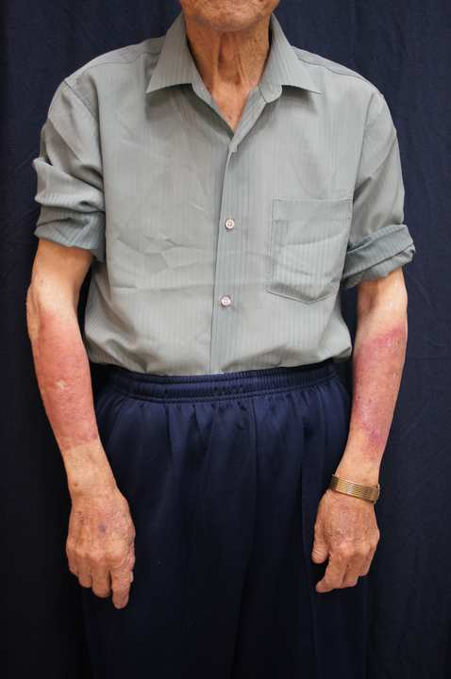
Figure(s)
Common.Links.ClickHereToDownloadHighResolutionImage
