Virulence and Plasmid Transferability of KPC Klebsiella pneumoniae at the
Veterans Affairs Healthcare System of New Jersey

L. Kristopher Siu,^{1,2} Jung-Chung Lin,³ Eric Gomez,⁴ Robert Eng,⁴ Tom Chiang⁴
¹Division of Infectious Diseases, National Health Research Institutes; ²Graduate Institute of Basic Medical Science, China Medical University, Taichung; ³Division of Infectious Diseases and Tropical Medicine, Department of Internal Medicine, Tri-Service General Hospital; Taiwan

⁴Veterans Affairs New Jersey Healthcare System (VA NJHCS)
385 Tremont Ave., 111-ID
East Orange, NJ 07018
(973) 676-1000, ext 1383
Tom.Chiang@va.gov
Abstract
Klebsiella pneumoniae carbapenemase (KPC)-producing Klebsiella pneumoniae infections are associated with high mortality; however, little is known about the virulence determinants of KPC-producing K. pneumoniae. At the Veterans Affairs New Jersey Healthcare System (VA NJHCS), we investigated the virulence and plasmid transferability of 60 clinically unique KPC-containing K. pneumoniae isolates. All 60 isolates were negative for known virulence factors K1, K2, and K5 capsular antigens; rmpA; and the aerobactin gene by polymerase chain reaction. Isolates varied in their susceptibility to neutrophil phagocytosis, but were less resistant than the virulent serotype K1 isolate. Additionally, no deaths were seen on murine lethality studies. Conjugation results of this study showed that the bla_{KPC} gene can be transferred into an Escherichia coli J-53 strain but not to E. coli JP-995. However, the stability is very limited as E. coli J-53 does not retain bla_{KPC} -containing plasmids for any period of time. The lack of virulence factors in the set of KPC-producing K. pneumoniae studied suggests that morbidity and mortality may be due to detection issues or lack of effective antibiotics.
Introduction
Klebsiella pneumoniae (KP) is a pathogen associated with community acquired and nosocomial infections [1,2]. For the past decade, KP has become increasingly resistant to conventional antibiotics. Global monitoring of multiple drug resistant Gram-negative bacilli (GNB) isolated from intra-abdominal infections has shown that 26.2% of KP were positive for extended-spectrum beta-lactamase (ESBL) [3]. The increasing incidences of patients infected with ESBL-KP are driving the use of carbapenems because of their effectiveness against ESBL-producers. Most clinicians now agree that resistant KP like most resistant Enterobacteriacae, pose the greatest health risk for the foreseeable future as drug development programs have not kept in pace with resistance development in KP [4]. Because carbapenems are usually the last line of defense for the treatment of resistant Gram-negative pathogens, the development of carbapenemase producing KP is of great concern. The quick dissemination of carbapenemases found in KP is facilitated by bacterial plasmids. KPC producing KP was first reported in the United States in 2001 [5]. The rapid spread of KPC particularly in New York has been described as a threat, limiting treatment options [6]. KPC has become an increasingly prevalent type of carbapenemase in the United States [7], Israel [8] and also an emerging concern in South America, Europe and China [8,9,10]. The concomitance of bla_{KPC} with other resistant mechanisms is frequently encountered in nosocomial KP. At the Veteran’s Affairs New Jersey Healthcare System (VA NJHCS) KP has become the second most prevalent Gram negative pathogen; second only to Escherichia coli for the past four years (VA NJHCS antibiogram 2007-2010). In 2010, 16% of our KP were ertapenem resistant and 98% of the ertapenem resistant KP were bla_{KPC} positive by PCR [11]. Similar to the more recently described New Dehli metallo-beta-lactamase (NDM) strains, KPC producing isolates are likely to be resistant to other classes of antibiotics limiting therapeutic options for treating such infections resulting in higher mortality rates and treatment failures [12,13]. The question of virulence or resistance accounting for the high attributable mortality in KPC producing KP has not been investigated. However, in KPC negative KP, virulence has been well documented [2,14]. K1, K2, and K5 capsular antigens along with the mucoid capsular phenotype are considered the main virulence factors in KP. Other virulence factors associated with KP include the extracapsular polysaccharide synthesis regulator gene (rmpA) related to the hypermucoviscosity phenotype, the ferric iron uptake system gene (kfu) required for the metabolism of iron to sustain growth in the host and aerobactin, an iron siderophore which can increase murine lethality by 100- fold [15,16,17]. Although virulence determinants have been well described in KP very little is known about the virulence of KPC producing KP. The objective of this study is to investigate the virulence factors of KPC containing KP, the lethality in murine model, its conjugation and plasmid stability, and neutrophilic phagocytosis rates.

Results
Antimicrobial susceptibility, PFGE and KPC types among 60 clinically unique βla_{KPC} isolates.
Among 60 clinically unique KPC positive KP isolates, 100% resistance was found to ampicillin, piperacillin-tazobactam, cefazolin, cefotaxime, ceftazidime, ceftriaxone and ciprofloxacin followed by 92% resistance to cefoxitin and 33% to gentamicin. Reduced susceptibility to imipenem and/or meropenem was seen in 95% of the isolates (Table 1). Sequencing results showed that two types of KPC (17 KPC-2 and 43 KPC-3 isolates). All 60 isolates were genetically diverse according to PFGE (similarity coefficient 80%) with only a few clusters being observed (Figure 1).
Conjugation and βla_{KPC} plasmid stability test.
On day 1 of conjugation experiments, plasmids carrying bla_{KPC} from parental non-serotype K2 KP was successfully transferred to sodium azide-resistant E. coli J-53. E. coli J-53:: bla_{KPC,} transconjugants were obtained from MacConkey agar plate containing azide (100μg/ml) and imipenem (2μg/ml) (Fig. 2A). Sub-culture E. coli J-53:: bla_{KPC} into the same selective plates showed no growth of E. coli J-53:: bla_{KPC} transconjugants suggesting the loss of bla_{KPC} or instability of bla_{KPC} plasmid in E. coli (Fig. 2B). By using E. coli J-53::bla_{KPC} transconjugants obtained directly from day 1 selective agar plate for conjugation with recipient serotype K2 pneumonia KP, transconjugants of serotype K2 K. pneumoniae::bla_{KPC} were obtained by Klebsiella-selective medium BIND supplemented with 2 μg/ml of imipenem (Fig. 2C). In contrast to E. coli J-53:: bla_{KPC,} sub-culture of serotype K2 K. pneumoniae:: bla_{KPC} onto the same selective agar plate showed good growth in the same selective BIND agar plate (Fig. 2D). No plasmid loss after 14 days of sub-culture onto MacConkey or Muller Hinton agar plate was observed for K2 K. pneumoniae:: bla_{KPC} indicating the stability of bla_{KPC} plasmid in KP (Fig. 2E). All strains were verified by PCR to ensure that no contamination occurred during each experiment for donor, recipient of E. coli J-53, transconjugants of E. coli J-53:: bla_{KPC}, recipient of serotype K2 KP or transconjugants K2 K. pneumoniae:: bla_{KPC} (Fig. 2F).

Neutrophil phagocytosis and mice lethality experiments and detection of virulence associated serotypes and rmpA and aerobactin genes
Detection of K1, K2, and K5 virulence associated serotypes, and rmpA and aerobactin genes, revealed that all 60 isolates were non-K1, -K2, or –K5 serotypes and did not carry rmpA and aerobactin gene. Twenty-five isolates were selected for neutrophil phagocytosis assays based on their diversity of PFGE profiles (Figure 1). These isolates varied in neutrophil phagocytic resistance (Figure 3). Seven isolates were phagocytic resistant as determined by the phagocytosis rate calculated using the percentage of neutrophils ingested FITC-labeled bacteria over time. Phagocytic rates around 25-35% at 15 minutes and susceptible phagocytic rate >40% at 15 minutes respectively were selected for further mice lethality studies. Murine lethality studies by IP injection showed that LD₅₀ were >10⁶ cfu for all seven isolates indicating low virulence. KPC containing plasmid transferability into E coli J-53 strain was achieved but plasmid stability in E. coli was limited.

Discussion
KPC KP has become an increasing prevalent pathogen and is now endemic in the Northeastern United States [6,17,18]. Clinical mortality due to KPC KP has been well documented (Michelle Morris, University of Miami Hospital ICAAC/IDSA 2008 poster, K-902.) [7]. However, virulence and plasmid transmissibility of KPC KP has not been well investigated. The findings in this study hope to increase the understanding of virulence, relatedness, and plasmid transmissibility of KPC containing KP. KPC containing KP causing infections are usually associated with resistance to multiple classes of antibiotics and treatment options are very limited. Furthermore, testing for KPC has been problematic [11]. In this study, all 60 specimens were positive for the bla_{KPC} gene by PCR and 95% were nonsusceptible to imipenem by broth microdilution method [19]. However, when using the old CLSI breakpoints, instead of the newly modified criteria (CLSI, June 2010), nearly three quarters of these specimens were reported as sensitive to the carbapenems. Since our KPC producing strains were collected before the newly applied criteria, therapy may have been misguided based on incorrect carbapenem susceptibility reports. Improper therapy may contribute to the increased morbidity and mortality seen in KPC KP infections. Furthermore, few KPC producing strains that remain susceptible according to newly documented criteria are of concern. Although low level expression of KPC may not contribute to clinical failure, no clinical investigation has fully confirmed this suggestion.

At the VA NJHCS, analysis of the bla_{KPC} gene shows only two variants: either KPC-2 or KPC-3. PFGE reveals that although there are several related clusters, there is wide heterogeneity in the KPC containing KP. Previous studies have shown clonal spread of KPC producing KP at this institution from New York City hospitals [18]. This more recent study reveals that as KPC KP becomes more prevalent at this institution, it is losing its clonal relatedness.

Probing for known KP virulence factors, these 60 KPC KP isolates did not contain genes for K1, K2, K5 capsular antigens, rmpA or the aerobactin gene. In addition, intra-peritoneal injections of KPC KP in murine lethality models did not cause mortality even at a very high dose of >10⁶ cfu of KP. The combination of the lack of KP virulence factors and no deaths seen in murine models suggests that mortality in KPC producing KP infections may not be attributed to increased virulence.

Transmissibility of plasmids containing the bla_{KPC} gene to other Enterobacteriacae has also been of great concern. Although the conjugation results of this study showed that the bla_{KPC} gene can be transferred into E. coli J-53 strain, it’s stability is very limited as E. coli J-53 does not seem to be able to retain bla_{KPC} for any period of time. The bla_{KPC} containing plasmid is conjugable but was most stable on a species specific level. These results seem to agree with what we see at the VA NJHCS. Since the first reporting of KPC KP at VA NJHCS in 2007, we have not seen carbapenem resistant E. coli. However, although rare, E. coli containing bla_{KPC} has been documented [20]. This may be due to the difference in the strains of E. coli. A previous study has shown that stability and frequency of plasmid conjugal transfer is varied due to genetic elements such as replicons, transposons, etc.. [21] In this study, transmission of KPC plasmid could be obtained in the first day co-culturing of donor KP and recipient E. coli. However, losing carbapenem resistance by single colony sub-culture of the transconjugant into the same medium after 24 hours suggests the lack of genetic elements required for maintaining the stability of KPC plasmid in recipient E. coli. Further investigation on the transmissibility of these KPC containing E. coli needs to be done.

As KPC KP has become more prevalent at the VA NJHCS there is a disturbing trend with the loss of clonality and increasing heterogeneity. Newly applied carbapenem breakpoints reduces improper report on susceptibility and enhancing the choose of appropriate therapy.

Important findings in this study revealed the KPC containing KP does not have known virulence factors found in KP strains causing liver abscesses in Asia. Furthermore, no murine deaths on lethality studies suggest that mortality due to KPC KP is not due to increased virulence. Other contributing factors may include advance age, procedures, line placement, and many other reported risk factors. However, further dissemination of the KPC plasmid into virulent types of KP can not be excluded in the future. More clinical studies are needed to assess attributable mortality in KPC KP with non KPC KP infections.

Materials and Methods
From January 2007 to June 2010, 60 clinically unique, ertapenem resistant KP isolates were acquired from the clinical microbiology laboratory at the VA NJHCS for this IRB approved study (MIRB 00937). Virulence and conjugation testing was performed at the National Health Research Institutes of Taiwan.

Susceptibility testing. Antimicrobial susceptibility was determined by broth microdilution method [19], according to the Clinical and Laboratory Standards Institute (CLSI) guidelines published in 2011. The following antimicrobial agents were used: ampicillin, cefazolin, amoxicillin/clavulanic acid, cefoxitin, cefotaxime, ceftazidime, imipenem, amikacin, gentamicin, ciprofloxacin, and trimethoprim-sulfamethoxazole. All drugs were incorporated into Mueller-Hinton broth (Trek Diagnostic System Ltd., West Sussex, United Kingdom) in serial two fold concentrations from 0.025 to 32μg/ml. Two control strains, Escherichia coli ATCC 35218 and ATCC 25922, were included for each test run. Inoculated plates were incubated at 35°C for 16 to 18 hours. The minimum inhibitory concentration (MIC) of each antimicrobial agent was defined as the lowest concentration that inhibited visible growth of the organism.

.

Confirmation of KPC production and KPC types by sequencing. All isolates selected were confirmed for KPC production by PCR. A gene-specific primer set, KPC-F (5’-ATG TCA CTG TAT CGC CGT CT-3’) and KPC-R (5’-TTT TCA GAG CCT TAC TGC CC-3’), was used to determine the presence of the KPC β-lactamase sequence [22]. The amplicons (893bp) were sequenced using an automated sequencer by the Sanger method (ABI Prism 377 sequencer; Perkin-Elmer) [23]. The generated sequences were compared to the National Center for Biotechnology Information (NCBI) database at www.ncbi.nlm.nih.gov/blast/.

Conjugation experiments. In this part of the study, two consecutive conjugation experiments were performed. In the first set of experiments, sodium azide-resistant strain E. coli J-53 (kindly provided by Prof. Jacoby, Division of Infectious Diseases, Massachusetts General Hospital, Boston, Massachusetts) was used as recipient [24]. None of the donor strains or wild-type KP with KPC could grow on MacConkey agar with sodium azide (100 μg/ml). The recipient and donor strains were inoculated separately into brain heart infusion broth (Oxoid, Basingstoke, Hampshire, England) and were incubated at 37°C for 4 hours. They were then mixed together at a ratio of 1:10 (by volume) and were incubated overnight at 37°C. A 0.1-ml volume of the overnight broth mixture was then spread onto a MacConkey agar plate containing azide (100μg/ml) and imipenem (2μg/ml). Transconjugants were then selected from the agar plate.

In second phase of conjugation experiments, the transconjugant of E. coli J-53 containing the KPC plasmid acted as a donor. A serotype K2 KP with intrinsic resistance only to ampicillin was used as recipient. Mating procedure was described as above except by using specific selection BIND (brilliant green agar containing inositol-nitrate-deoxycholate) for KP [25]. Serotype K2 KP transconjugants were selected using the Klebsiella-selective medium BIND supplemented with 2 μg/ml of imipenem. None of the donors including E. coli J-53 with KPC, recipient, and serotype K2 K. pneumoniae, could grow on the selective BIND medium with imipenem. The only colonies that could grow on BIND with imipenem were the serotype K2 KP strain harboring the imipenem-resistant KPC plasmid. Transconjugants from first and second round conjugation experiments were sub-cultured onto MacConkey or Mueller Hinton agar (BBL, Sparks, MD) for 14 days to check for KPC plasmid stability in E. coli and KP after conjugation.

PFGE analysis. Total DNA was prepared, and pulsed-field gel electrophoresis (PFGE) was performed as described previously [26]. The restriction enzyme XbaI (New England Biolabs, Beverly, MA) was used at the temperature suggested by the manufacturer. Restriction fragments were separated by PFGE in a 1% agarose gel (Bio-Rad, Hercules, CA) in 0.5×TBE buffer (45 mM Tris, 45 mM boric acid, 1.0 mM EDTA, pH 8.0) for 22 hours at 200 Volts at a temperature of 14°C and with ramp times of 2 to 40 seconds by using a CHEF Mapper apparatus (Bio-Rad Laboratories, Richmond, CA). The gels were then stained with ethidium bromide and photographed under UV light. The resulting genomic DNA profiles, or fingerprints, were interpreted according to established guidelines [27,28].

PCR detection of virulence associated genes rmpA and aerobactin, and serotypes K1 and K2. PCR experiments to determine the presence of the specific genes for serotype K1, K2 and K5, rmpA and the aerobactin gene were performed as previously described [2].

Virulence study
In vitro and in vivo assays to assess virulence were performed by neutrophil phagocytosis and mice lethality experiments. Neutrophils phagocytosis was performed as previously described [29]. For the determination of LD50 in mice, pathogen-free, adult, 6–8 week-old, male BALB/c mice weighing 20–25 g were obtained from the National Laboratory Animal Center (Taipei, Taiwan). This study was carried out in strict accordance with the recommendations in the Guide for the Care and Use of Laboratory Animals of the National Institutes of Health. All animal care procedures and protocols were approved by the Institutional Animal Care and Use Committee of the National Health Research Institute (NHRI-IACUC-096004-A). -Ten-fold serial dilutions of KP were made from a starting concentration of 10⁶ colony forming unit (cfu) and the adult BALB/c mice had intraperitoneal injections with 0.1 mL of each concentration . Six mice were used as a sample population for each bacterial concentration [30]. Symptoms and signs of infection were observed for 14 days. Survival of the inoculated mice was recorded and the LD50 was calculated using SigmaPlot version 7.0 from SPSS Inc. (Chicago, IL, USA).

Acknowledgement:
This work was supported by grants from the National Science Council (NSC-98-2314-B-016-024-MY3), Taiwan Center for Diseases Control (DOH-100-DC-1025) and from the National Health Research Institutes, Taiwan.

References:
1. Keynan Y, Rubinstein E (2007) The changing face of Klebsiella pneumoniae infections in the community. Int J Antimicrob Agents 30: 385-389.
2. Turton JF, Baklan H, Siu LK, Kaufmann ME, Pitt TL (2008) Evaluation of a multiplex PCR for detection of serotypes K1, K2 and K5 in Klebsiella sp. and comparison of isolates within these serotypes. FEMS Microbiol Lett 284: 247-252.
3. Hawser SP, Bouchillon SK, Hoban DJ, Badal RE (2009) In vitro susceptibilities of aerobic and facultative anaerobic Gram-negative bacilli from patients with intra-abdominal infections worldwide from 2005-2007: results from the SMART study. Int J Antimicrob Agents 34: 585-588.
4. Kumarasamy KK, Toleman MA, Walsh TR, Bagaria J, Butt F, et al. Emergence of a new antibiotic resistance mechanism in India, Pakistan, and the UK: a molecular, biological, and epidemiological study. Lancet Infect Dis 10: 597-602.
5. Yigit H, Queenan AM, Anderson GJ, Domenech-Sanchez A, Biddle JW, et al. (2001) Novel carbapenem-hydrolyzing beta-lactamase, KPC-1, from a carbapenem-resistant strain of Klebsiella pneumoniae. Antimicrob Agents Chemother 45: 1151-1161.
6. Bratu S, Landman D, Haag R, Recco R, Eramo A, et al. (2005) Rapid spread of carbapenem-resistant Klebsiella pneumoniae in New York City: a new threat to our antibiotic armamentarium. Arch Intern Med 165: 1430-1435.
7. Endimiani A, Hujer AM, Perez F, Bethel CR, Hujer KM, et al. (2009) Characterization of blaKPC-containing Klebsiella pneumoniae isolates detected in different institutions in the Eastern USA. J Antimicrob Chemother 63: 427-437.
8. Leavitt A, Navon-Venezia S, Chmelnitsky I, Schwaber MJ, Carmeli Y (2007) Emergence of KPC-2 and KPC-3 in carbapenem-resistant Klebsiella pneumoniae strains in an Israeli hospital. Antimicrob Agents Chemother 51: 3026-3029.
9. Cuzon G, Naas T, Demachy MC, Nordmann P (2008) Plasmid-mediated carbapenem-hydrolyzing beta-lactamase KPC-2 in Klebsiella pneumoniae isolate from Greece. Antimicrob Agents Chemother 52: 796-797.
10. Wei ZQ, Du XX, Yu YS, Shen P, Chen YG, et al. (2007) Plasmid-mediated KPC-2 in a Klebsiella pneumoniae isolate from China. Antimicrob Agents Chemother 51: 763-765.
11. Gomez E, Urban C, Mariano N, Colon-Urban R, Eng RH, et al. (2011) Phenotypic and Genotypic Screening and Clonal Analysis of Carbapenem-Resistant Klebsiella pneumoniae at a Single Hospital. Microb Drug Resist.
12. Elemam A, Rahimian J, Mandell W (2009) Infection with panresistant Klebsiella pneumoniae: a report of 2 cases and a brief review of the literature. Clin Infect Dis 49: 271-274.
13. Weisenberg SA, Morgan DJ, Espinal-Witter R, Larone DH (2009) Clinical outcomes of patients with Klebsiella pneumoniae carbapenemase-producing K. pneumoniae after treatment with imipenem or meropenem. Diagn Microbiol Infect Dis 64: 233-235.
14. Yu WL, Ko WC, Cheng KC, Lee CC, Lai CC, et al. (2008) Comparison of prevalence of virulence factors for Klebsiella pneumoniae liver abscesses between isolates with capsular K1/K2 and non-K1/K2 serotypes. Diagn Microbiol Infect Dis 62: 1-6.
15. Fang CT, Chuang YP, Shun CT, Chang SC, Wang JT (2004) A novel virulence gene in Klebsiella pneumoniae strains causing primary liver abscess and septic metastatic complications. J Exp Med 199: 697-705.
16. Ma LC, Fang CT, Lee CZ, Shun CT, Wang JT (2005) Genomic heterogeneity in Klebsiella pneumoniae strains is associated with primary pyogenic liver abscess and metastatic infection. J Infect Dis 192: 117-128.
17. Woodford N, Tierno PM, Jr., Young K, Tysall L, Palepou MF, et al. (2004) Outbreak of Klebsiella pneumoniae producing a new carbapenem-hydrolyzing class A beta-lactamase, KPC-3, in a New York Medical Center. Antimicrob Agents Chemother 48: 4793-4799.
18. Chiang T, Mariano N, Urban C, Colon-Urban R, Grenner L, et al. (2007) Identification of carbapenem-resistant klebsiella pneumoniae harboring KPC enzymes in New Jersey. Microb Drug Resist 13: 235-239.
19. CLSI (2010) Clinical and Laboratory Standards Institute. Performance standards for antimicrobial susceptibility testing; 20th informational supplement M100-S17. Wayne, PA: Clinical and Laboratory Standards Institute.
20. Landman D, Urban C, Backer M, Kelly P, Shah N, et al. (2010) Susceptibility profiles, molecular epidemiology, and detection of KPC-producing Escherichia coli isolates from the New York City vicinity. J Clin Microbiol 48: 4604-4607.
21. Ambrozic J, Ostroversnik A, Starcic M, Kuhar I, Grabnar M, et al. (1998) Escherichia coli CoIV plasmid pRK100: genetic organization, stability and conjugal transfer. Microbiology 144 ( Pt 2): 343-352.
22. Bradford PA, Bratu S, Urban C, Visalli M, Mariano N, et al. (2004) Emergence of carbapenem-resistant Klebsiella species possessing the class A carbapenem-hydrolyzing KPC-2 and inhibitor-resistant TEM-30 beta-lactamases in New York City. Clin Infect Dis 39: 55-60.
23. Sanger F, Air GM, Barrell BG, Brown NL, Coulson AR, et al. (1977) Nucleotide sequence of bacteriophage phi X174 DNA. Nature 265: 687-695.
24. Wang M, Tran JH, Jacoby GA, Zhang Y, Wang F, et al. (2003) Plasmid-mediated quinolone resistance in clinical isolates of Escherichia coli from Shanghai, China. Antimicrob Agents Chemother 47: 2242-2248.
25. Yeh KM, Lin JC, Yin FY, Fung CP, Hung HC, et al. (2010) Revisiting the importance of virulence determinant magA and its surrounding genes in Klebsiella pneumoniae causing pyogenic liver abscesses: exact role in serotype K1 capsule formation. J Infect Dis 201: 1259-1267.
26. D'Agata EM, Gerrits MM, Tang YW, Samore M, Kusters JG (2001) Comparison of pulsed-field gel electrophoresis and amplified fragment-length polymorphism for epidemiological investigations of common nosocomial pathogens. Infect Control Hosp Epidemiol 22: 550-554.
27. McDougal LK, Steward CD, Killgore GE, Chaitram JM, McAllister SK, et al. (2003) Pulsed-field gel electrophoresis typing of oxacillin-resistant Staphylococcus aureus isolates from the United States: establishing a national database. J Clin Microbiol 41: 5113-5120.
28. Tenover FC, Arbeit RD, Goering RV, Mickelsen PA, Murray BE, et al. (1995) Interpreting chromosomal DNA restriction patterns produced by pulsed-field gel electrophoresis: criteria for bacterial strain typing. J Clin Microbiol 33: 2233-2239.
29. Lin JC, Chang FY, Fung CP, Xu JZ, Cheng HP, et al. (2004) High prevalence of phagocytic-resistant capsular serotypes of Klebsiella pneumoniae in liver abscess. Microbes Infect 6: 1191-1198.
30. Chen JH, Siu LK, Fung CP, Lin JC, Yeh KM, et al. (2010) Contribution of outer membrane protein K36 to antimicrobial resistance and virulence in Klebsiella pneumoniae. J Antimicrob Chemother 65: 986-990.

Table 1. Antimicrobial susceptibility testing results among 60 K. pneumoniae isolates with KPC production.
Antibiotic | MIC (n=60) |  |  |  | Susceptibility (%)
 | Range | MIC₅₀ | MIC₉₀ |  | S* | I | R
Ampicillin | ≥32 | ≥32 | ≥32 |  | 0 | 0 | 100
Piperacillin/tazobactam | ≥128 | ≥128 | ≥128 |  | 0 | 0 | 100
Cefazolin | ≥32 | ≥32 | ≥32 |  | 0 | 0 | 100
Cefoxitin | 16 - ≥128 | 32 | ≥128 |  | 0 | 8 | 92
Cefotaxime | 4 - ≥128 | 32 | ≥128 |  | 0 | 0 | 100
Cefotaxime/clavulanic acid | 0.5 - ≥128 | 16 | 32 |  | NA | NA | NA
Ceftazidime | 32 - ≥256 | ≥256 | ≥256 |  | 0 | 0 | 100
Ceftazidime / clavulanic acid | 4 - ≥256 | 64 | ≥256 |  | NA | NA | NA
Ceftriaxone | 16 - ≥256 | 64 | ≥256 |  | 0 | 0 | 100
Imipenem | ≤0.5 - ≥32 | 8 | ≥32 |  | 5 | 3 | 92
Meropenem | ≤1 - ≥16 | 8 | ≥16 |  | 5 | 5 | 90
Gentamicin | ≤4 - ≥32 | ≤4 | ≥32 |  | 37 | 30 | 33
Ciprofloxacin | ≥4 | ≥4 | ≥4 |  | 0 | 0 | 100
*S, susceptible; I, intermediate and R, resistance. NA, not available.
Figures legends

Figure 1. PFGE analysis by XbaI restriction enzyme digestion of 60 K. pneumoniae isolates harboring bla_{KPC}. Dendrogram was generated by the unweighted pair group method using arithmetic averages (UPGMA) clustering. Parameters for calculation of bands correlation: Dice (tolerance, 1%; optimization 0.5%, minimum height 0%; minimum surface 0%; change towards end of fingerprint,%. Similarities >80% was used to represent the clonal spread of strains. Isolate number and isolates used for phagocytosis (*) and lethality study (†) are listed on the right side of the figure.

Figure 2. Conjugation experiments of plasmids carrying βla_{KPC} from parental non-serotype K2 K. pneumoniae to sodium azide-resistant E. coli J-53 strains and to recipient serotype K2 K. pneumoniae. A, Transconjugants, E. coli J-53:: bla_{KPC} were obtained on day 1 using MacConkey agar plates containing azide (100μg/ml) and imipenem (2μg/ml); B, Sub-culture of E. coli J-53:: bla_{KPC} by inoculating into the same selective agar plate; C, Second round of conjugation experiments using E. coli J-53:: bla_{KPC} obtained directly from day 1 selective agar procedure and recipient serotype K2 K. pneumoniae. Transconjugants, K2 K. pneumoniae::bla_{KPC}, were obtained by Klebsiella-selective medium BIND supplemented with 2 µg/ml of imipenem; D, Sub-culture transconjugants K2 K. pneumoniae:: bla_{KPC} onto the same selective agar plate. E. Sub-culture of K2 K. pneumoniae:: bla_{KPC} by inoculating onto MacConkey agar plates for 14 consecutive days; F, PCR verification of donor K. pneumoniae with bla_{KPC} (Lane 1), transconjugants E. coli J-53:: bla_{KPC} (lane 2), recipient serotype K2 K. pneumoniae (lane 3) and transconjugants K2 K. pneumoniae:: bla_{KPC} (lane 4).

Figure 3. Phagocytosis assay for randomly selected bla_{KPC} isolates. The phagocytosis rate was calculated using the percentage of neutrophils ingested FITC-labeled bacteria over the time. The bla_{KPC} isolates are labeled as filled diamonds. Serotype K1 isolates obtained from previous studies [25] were used as a control for virulence assessment. STL-43 (open triangle) was obtained from liver abscess patients. STL43ΔrfbP (open rectangle) and STL43ΔWzy_{KPK1} (open circle) were capsule deficient nonpolar-rfbP and- Wzy_{KPK1} mutant strains derived from STL-43 respectively [30].

Figure 1
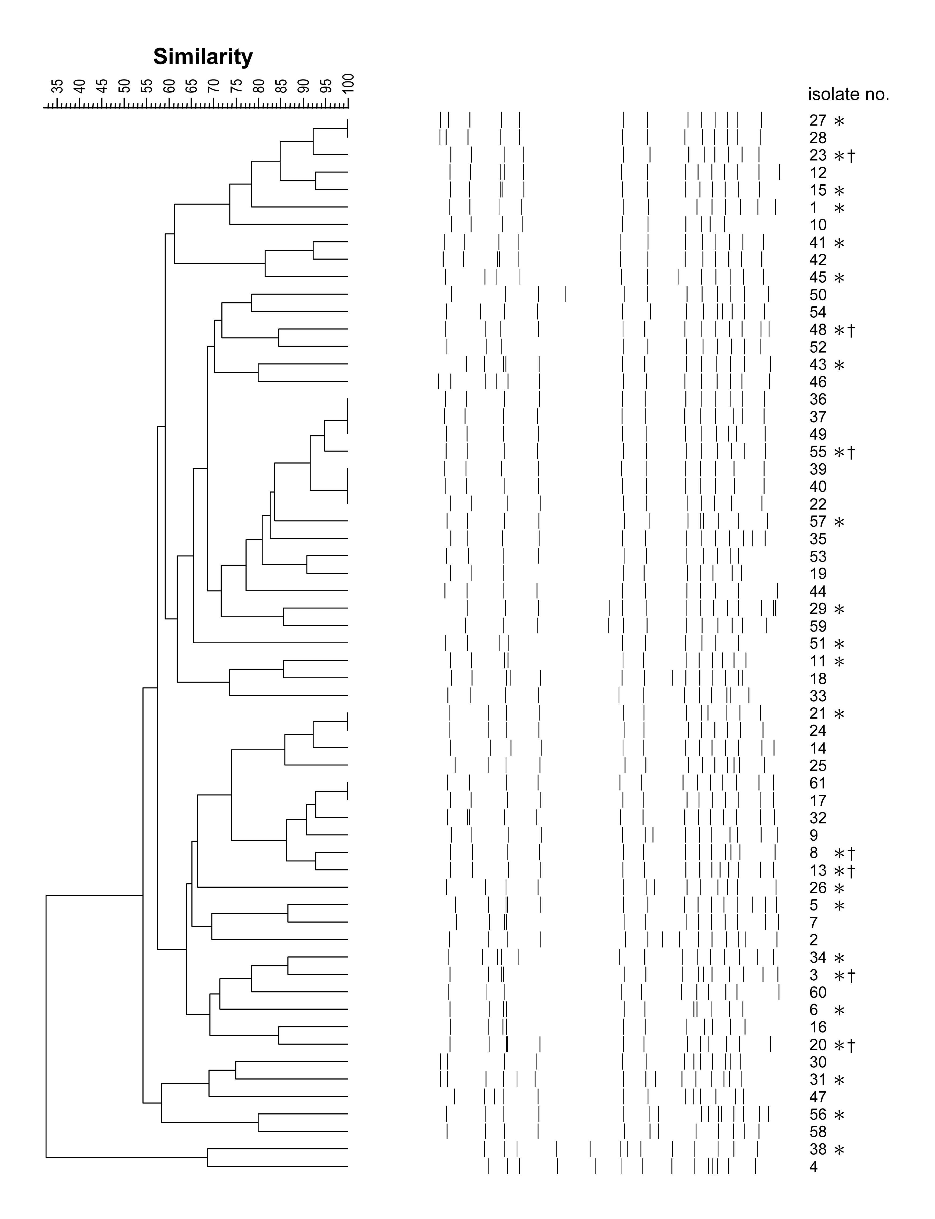
Figure 2.
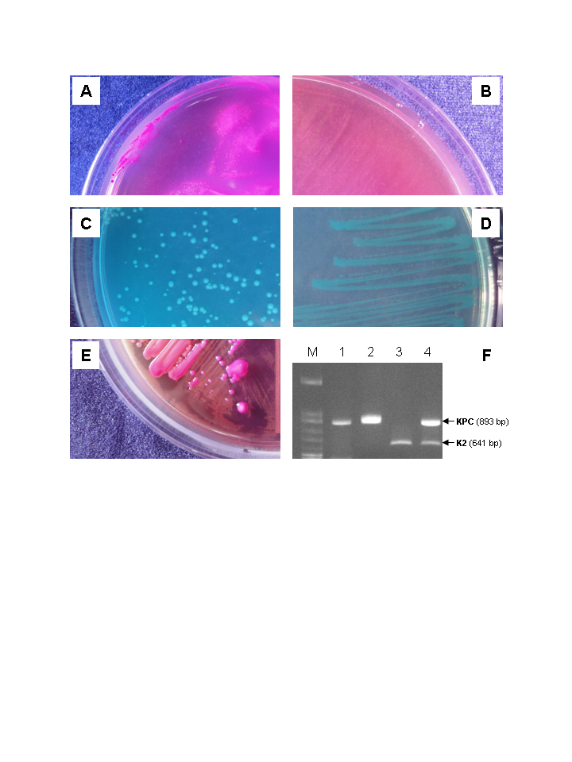
Figure 3.

