
Journal of Ethnopharmacology 142 (2012) 811–818
Contents lists available at SciVerse ScienceDirect
Journal of Ethnopharmacology
journal homepage: www.elsevier.com/locate/jep
A Chinese herbal medicine, Gexia-Zhuyu Tang (GZT), prevents
dimethylnitrosamine-induced liver ﬁbrosis through inhibition
of hepatic stellate cells proliferation
Jiun-Yu Chen a,b,1, Hsiao-Ling Chen c,1, Ju-Chien Cheng d,1, Hung-Jen Lin e, Yu-Tang Tung a,
Chia-Fan Lin d, Chuan-Mu Chen a,e,n
a
Department of Life Sciences, and Agricultural Biotechnology Center, National Chung Hsing University, Taichung 402, Taiwan
Center for Nanomedicine Research, National Health Research Institutes, Zhunan, Miaoli County 350, Taiwan
cDepartment of Bioresources and Molecular Biotechnology, Da-Yeh University, Changhwa 515, Taiwan
dDepartment of Medical Laboratory Science and Biotechnology, China Medical University, Taichung 404, Taiwan
eSchool of Chinese Medicine, China Medical University, Taichung 404, Taiwan
b
a r t i c l e i n f o
Article history:
Received 1 May 2012
Received in revised form
27 May 2012
Accepted 5 June 2012
Available online 15 June 2012
Keywords:
Gexia-Zhuyu Tang (GZT)
Gexiazhuyu decoction (GXZYD)
Herb medicine
Hepatic ﬁbrosis
Dimethylnitrosamine (DMN)
Hepatic stellate cells (HSCs)
abstract
Ethnopharmacological evidence: Gexia-Zhuyu Tang (GZT), also called Gexiazhuyu decoction (GXZYD), is
a traditional Chinese herbal medicine for chronic liver diseases such as cirrhosis and liver ﬁbrosis.
Aim of the study: In this study, we have investigated the affects of GZT on a rat model of
dimethylnitrosamine (DMN)-induced liver ﬁbrosis.
Materials and methods: In this study, the protective effects of GZT on DMN-induced liver ﬁbrosis were
measured using a rat model. Following 5 weeks of DMN-treatment (8 mg/kg, i.p., given 3 consecutive
days each week), oral administration of GZT at 1.8 g/kg daily via oral gavage for 2 weeks beginning at
week 13.
Results: Both body and liver weights were signiﬁcantly decreased. The reductions in body and liver
weights corresponded with increasing liver damage severity. Furthermore, GZT-treatment remarkably
decreased the levels of serum GOT (glutamate oxaloacetate transaminase) and GPT (glutamic pyruvic
transaminase), and the mRNA expression levels of collagen alpha-1(I) and alpha-smooth muscle actin
(alpha-SMA) in DMN-induced hepatic ﬁbrosis. In addition, hepatic stellate cells (HSCs) play a major role
in various types of liver ﬁbrosis through initial myoﬁbroblast transformation. The proliferation of HSCs
was inhibited by GZT. Treatment with GZT also induced HSC apoptosis in a dose- and time-dependent
manner. GZT treatment induced HSC apoptosis by facilitating Ca2 þ release from the mitochondria
within 6 h. Subsequently, caspases 3 and 12 were elevated by 72 h after treatment.
Conclusions: Our studies indicate that GZT exhibited both hepatoprotective and antiﬁbrogenic effects in
DMN-induced hepatic injury. These ﬁndings suggest that GZT may be useful in preventing the
development of hepatic ﬁbrosis.
& 2012 Elsevier Ireland Ltd. All rights reserved.
1. Introduction
Liver ﬁbrosis is a crucial factor in the development of liver
disease. Liver ﬁbrosis can lead to cirrhosis, liver failure and portal
hypertension. These diseases are caused by various factors such as
viral hepatitis, alcohol abuse, biliary atresia and hepatotoxins.
Hepatic stellate cells (HSCs) synthesize excess matrix elements
that contribute to liver ﬁbrosis and cirrhosis (Tsukada et al.,
Corresponding author at: Department of Life Sciences, Ofﬁce of Research and
Development, National Chung Hsing University, No. 250, Kuo Kuang Road,
Taichung 402, Taiwan. Tel.: þ886 4 2285 6309; fax: þ886 4 2287 4740.
E-mail address: chchen1@dragon.nchu.edu.tw (C.-M. Chen).
1Authors contributed equally to this work.
0378-8741/$ - see front matter & 2012 Elsevier Ireland Ltd. All rights reserved.
http://dx.doi.org/10.1016/j.jep.2012.06.005
n
2006). Activated HSCs are proliferating cells that secrete extra-
cellular matrix proteins, including collagen type I and alpha-
smooth muscle actin (alpha-SMA). Moreover, activated HSCs are
involved in hepatic injury. Activated HSCs can also secrete
cytokines that contribute to liver ﬁbrogenesis (Friedman, 2003;
Elsharkawy et al., 2005). The HSCs are a crucial cell type in the
injured liver, and their activation is associated with speciﬁc
cytoskeletal and phenotypic proﬁles (Friedman, 2003). Therefore,
the induction of HSC apoptosis has been proposed as a strategy to
treat liver ﬁbrosis (Bataller and Brenner, 2005).
Dimethylnitrosamine (DMN) is a hepatotoxin that is known to
cause acute liver injury in laboratory animals. This DMN-induced
liver ﬁbrosis model reproduces the features of human liver
ﬁbrosis (Jezequel et al., 1987). Analyzing a model of advanced
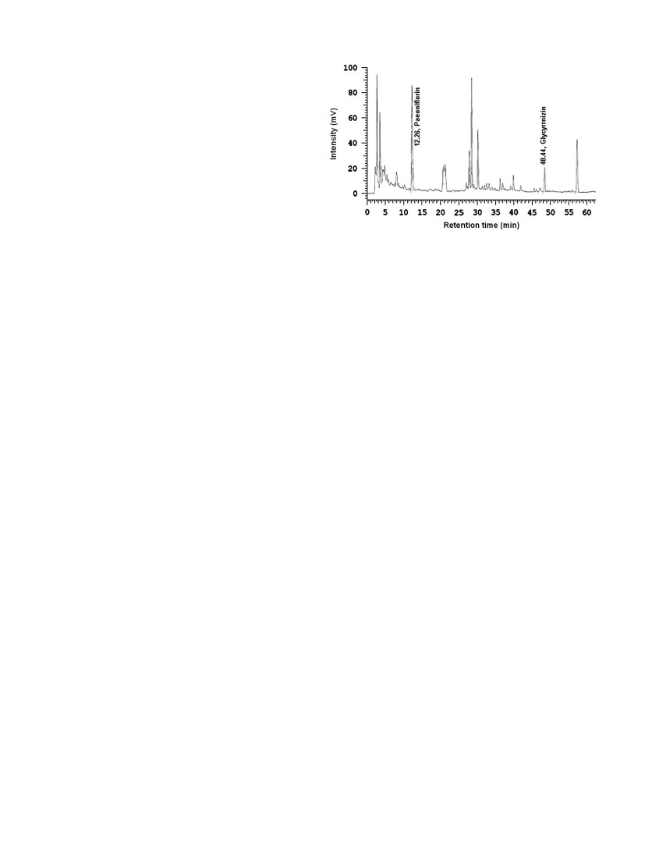
812
J.-Y. Chen et al. / Journal of Ethnopharmacology 142 (2012) 811–818
liver ﬁbrosis and the process of therapeutic recovery may provide
key insights into the mechanism of ﬁbrosis. Liver histology is the
clinical gold standard for evaluating the degree of hepatic injury.
However, laboratory animal ultrasound can also be used to follow
the morphological changes associated with liver damage. An
ultrasound has the advantage of being a non-invasive diagnostic
method (Chen et al., 2012). There is mounting evidence suggest-
ing that an ultrasound image can be involved in determining the
pathophysiology of liver injury in vivo.
Traditional Chinese medicine (TCM) has a potential use in the
treatment of chronic diseases. TCM has also been an accepted
practice in medical care throughout East Asia for thousands of
years (Hu et al., 2011). Gexia-Zhuyu Tang (GZT), also called
Gexiazhuyu decoction (GXZYD), is traditionally used as a medic-
inal plant. An aqueous extract of GZT was used for blood stasis
(Wang, 2007). Moreover, in the present study, GZT is also used in
treating clinical chronic liver diseases such as liver ﬁbrosis and
cirrhosis (She et al., 2004). She et al. (2004) reported that GZT
exhibited an excellent anti-liver ﬁbrosis effect in treating chronic
hepatitis B caused liver ﬁbrosis. Furthermore, Ge et al. (1994)
showed that GZT had a good inhibitory effect of platelet aggrega-
tion that might be one of mechanisms of blood stasis treatment.
However, there is less scientiﬁc data investigating the mechanism
of hepatoprotective effects of GZT. Therefore, the objective of this
study was to evaluate the potential protective effects of GZT in a
DMN-induced chronic liver injury model using the Sprague–
Dawley (SD) rat. The therapeutic efﬁcacy of treating liver ﬁbrosis
was also evaluated in the HSC cell line, LX-2. Our results indicate
that GZT attenuates HSCs activation.
Fig. 1. HPLC chromatograms of GZT. Column: cosmosil 5C18-AR-II (250 Â
4.6 mm); mobile phase: acetonitrile-H3PO4 (acetonitrile: 15-50% in 75 min); ﬂow
rate: 1.0 mL/min; detection wavelength: 280 nm. Paeoniﬂorin and glycyrrhizin
were separated from GZT at a retention time 12.26 and 48.44 min, respectively.
were 15–50% A to B (linear gradient) for 75 min at a ﬂow rate of
1 mL/min using a detector set at a 280 nm wavelength (Chen et al.,
2008a).
2.3. Animals
Male Sprague–Dawley (SD) rats (aged 8–9 weeks and weigh-
ing 280–320 g) were purchased from the National Laboratory
Animal Center (Taipei, Taiwan) and fed a standard laboratory diet
and tap water ad libitum. The animals were housed in an air-
conditioned room at 23 73 1C, with 55–60% relative humidity and
a 12 h light/dark cycle (Wu et al., 2007; Chen et al., 2008b;
Yen et al., 2009). The animals were acclimatized for 1 week. Each
group contained six animals. All the experimental procedures
were approved by the Institutional Animal Care and Use Com-
mittee of the National Chung Hsing University (IACUC no. 98-54).
2.4. Animal treatment
A hepatic ﬁbrosis rat model was produced by administration of
toxic DMN (Wako, Osaka, Japan). After acclimatization of 1 week,
DMN was injected i.p. (intraperitoneal injection) for 5 weeks at a
concentration of 8 mg/kg per day. The DMN was injected for
3 consecutive days of each week. This dosing regimen was used to
induce hepatic ﬁbrosis as described previously (Lin et al., 2011a,
b). After treatment with DMN for 5 weeks, the animals were
administered either 1.8 g/kg GZT orally (n ¼6) or the same
volume of saline as a mock treatment (n ¼6). The rats were
treated every day for 2 weeks (Fig. 2). At the end of the
experimental period, all the animals were sacriﬁced for tissue
sampling and blood collection. The blood samples were allowed
to coagulate at 4 1C for 30 min. The serum was then separated by
centrifugation at 3000 rpm for 10 min at 4 1C (Hung et al., 2010;
Tung et al., 2011; Chen et al., 2008a). All the animal studies were
repeated twice.
2.5. Tissue hydroxyproline and Blood parameters
2. Materials and methods
2.1. Preparation of GZT
The herbal medicinal plants were sampled from Sichuan,
Shaanxi, and Shanxi provinces of China. The species were identi-
ﬁed by Dr. Hung-Jen Lin of School of Chinese Medicine, China
Medical University, and a voucher specimen was deposited at
Koda Pharmaceutics Ltd. (Taoyuan, Taiwan). The GZT is a mixture
of ingredients including Trogopterusxanthipes Milne-Edwards
excrements, Colla Carapace Testudinis, Eupolyphaga sinensis, Lin-
dera aggregate (Sims) Kosterm. root tuber, Angelica sinensis (Oliv.)
Diels root, Ligusticum chuanxiong Hortorum rhizome, Paeonia
veitchii Lynch., Prunus persica (L.) Batsch seed, Crocus sativus Linn.,
Paeonia suffruticosa Andr. root bark, Corydalis yanhusuo W. T.
Wang stem tuber, Cyperus rotundus L. rhizome, Poncirus trifolia
L., Astragalus membranaceus Fischer., Glycyrrhiza glabra L. root,
Rehmannia glutinosa Fischer., and Hedyotis diffusa Willd. The
samples were extracted with boiling double-distilled water.
The extract was decanted, vacuum ﬁltered and concentrated in
a rotary evaporator. The sample was then lyophilized (Hu et al.,
2011; Hung et al., 2011). The extracts were stored in an airtight
container at –80 1C prior to further analysis.
2.2. Chromatographic analysis of GZT
The GZT was dissolved in pyrogen-free isotonic saline (YF
Chemical, Taipei, Taiwan) and ﬁltered through a 0.2 mm ﬁlter
(Microgen, Laguna Hills, CA, USA) before high performance liquid
chromatography (HPLC) analyses (Fig. 1). HPLC analyses were
performed using a Cosmosil 5C18-AR-II column (25 mm Â
4.6 mm) at room temperature. Paeoniﬂorin and glycyrrhizin,
purchased from Sigma (St. Louis, MO, USA), were used as external
standards in the HPLC analyses. The mobile phase was solvent A,
100% acetonitrile, and solvent B was H3PO4. The elution conditions
The liver index (liver wet weight/body weight) and spleen
index (spleen wet weight/body weight) were calculated. The
concentrations of serum GOT and GPT were determined using a
JSCC kit (Roche, USA) (Chen et al., 2008d). The hydroxyproline
content in the liver tissue was measured as described previously
(Jamall et al., 1981). Brieﬂy, the liver tissue was dehydrated in
95% alcohol for 5–6 h and then defatted with acetone for 2 day.
The defatted tissue was dried in an oven at 65 1C for 2 day. An HCl
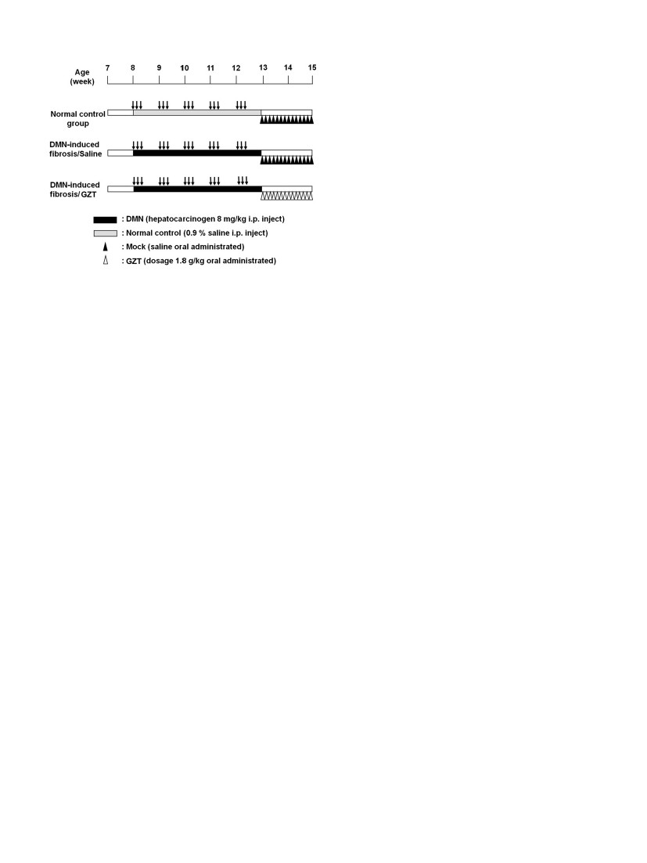
J.-Y. Chen et al. / Journal of Ethnopharmacology 142 (2012) 811–818
813
RNA was reverse-transcribed with MuLV Reverse Transcriptase
using the GeneAmp RNA PCR Kit (Applied Biosystems, Foster, CA)
and oligo d(T)16 primers. Aliquots of the reverse transcriptase
mix were used for PCR ampliﬁcation of alpha-SMA, collagen alpha-
1(I) and GAPDH. The primer sequences for these genes were
described previously (Lin et al., 2011a, b). The ampliﬁed RT-PCR
products were subjected to electrophoresis in a 2% agarose gel
(Invitrogen, Carlsbad, CA) for 30 min. The transcription levels of
each gene were normalized to GAPDH mRNA using a semi-
quantitative method (Chen et al., 2008c).
2.8. Cell culture and TUNEL assay
LX-2 cells are a human HSC cell line. The cells were maintained
in Dulbecco’s Modiﬁed Eagle’s Medium (DMEM) (Gibco-BRL)
supplemented with 10% fetal bovine serum (FBS) at 37 1C in a
humidiﬁed atmosphere of 5% CO2. To analyze cell proliferation,
the LX-2 cells were seeded into 96-well culture plates at a cell
density of 1 Â 104 cells/well for 24 h. The cells were then treated
with several concentrations of GZT. The number of cells per well
was estimated by ﬂow cytometry using a FACS Calibur (Beccton
Dickinson) after 24 or 72 h (Liu et al., 2008). A terminal deox-
ynucleotidyl transferase (TdT) dUTP nick end labeling (TUNEL)
assay was performed using the Fluorescein FragEL DNA Fragmen-
tation Detection Kit according to the manufacturer’s (EMD Che-
micals) instructions. Brieﬂy, LX-2 cells (1 Â 106 cells/35-mm
culture dish) were treated with the indicated dose of GZT. After
72 h of treatment, the cells were ﬁxed with 4% paraformaldehyde
at room temperature for 30 min. The ﬁxed cells were washed with
phosphate-buffered saline (PBS) and then cytospun to transfer the
cells onto glass slides. The cells were treated with proteinase K
(2 mg/mL) at room temperature for 5 min. Thirty minutes after the
addition of 100 mL of TdT equilibration buffer, the cells were
incubated with 60 mL of TdT Labeling Reaction Mix (containing
3 mL TdT) at 37 1C for 1 h. The slides were then washed with Tris-
buffered saline (TBS), and the stained cells were imaged using
ﬂuorescence microscopy (OLYMPUS, IX70) as described pre-
viously (Lin et al., 2011a, b). All the in vitro cell cultural
experiments were repeated in triplicate.
2.9. Measurements of cytosolic calcium concentrations
The cells were treated with 1 mM Fluo-4/AM (BIOCHEMIKA) in
the dark at room temperature for 30 min. The cells were washed
twice with 1X PBS. The cells were then analyzed by ﬂow
cytometry as described previously (Yen et al., 2011).
2.10. Western blotting
The cell cultures were washed with PBS and total cell lysates
were prepared by adding cell lysis buffer (50 mM HEPES, pH 7.5,
150 mM NaCl, 1% Triton X-100, 1.5 mM MgCl2, 10% glycerol,
protease inhibitor cocktail (Invitrogen). The proteins were sepa-
rated on a 10% SDS-polyacrylamide gel as described previously
(Yen et al., 2011). The membrane was blocked and then incubated
with primary antibodies overnight at 4 1C. The primary antibodies
used were anti-caspase 3, anti-caspase 12 and beta-actin.
The images were captured using a LAS-4000 mini imaging system
(GE Healthcare Life Sciences, CA, USA).
2.11. Statistical analysis
The results are expressed as the mean7SD. The signiﬁcance
values were calculated using the General Linear Model (GLM)
procedure by SAS as described previously (Chen et al., 2003).
All results with p o 0.05 were considered statistically signiﬁcant.
Fig. 2. The schematics for DMN-induction of liver ﬁbrosis and for GZT therapy.
DMN (8 mg/kg body weight) was given i.p. on 3 consecutive days per week for
5 weeks (black box). In the mock saline-treated group, saline alone was adminis-
tered daily for 2 weeks after cessation of DMN-treatment. In the GZT-treated
group, GZT was administered daily for 2 weeks after cessation of DMN-treatment.
(6 M) solution was added to the tube (at a ratio 1 mL HCl: 100 mg
dried liver powder) and hydrolyzed at 121 1C for 1 h. A NaOH
(6 N) solution was then added to the lysates to neutralize the pH.
The lysates were then ﬁltered, and the pH was adjusted to
between 6 and 6.5. A volume of 450 mL of chloramine T was
placed in a new tube and incubated for 25 min at room tempera-
ture. Then 500 mL of Ehrlich’s reagent was incubated with the
mixture for 20 min at 60 1C. Finally, the test tube was placed on
ice for 5 min to stop the reaction. The absorbance was measured
at 550 nm using a spectrophotometer (Beckman DU650, USA).
2.6. High-frequency ultrasound (HFU) examination
During the surgical procedures, all animals were lightly
anesthetized with a gas mixture consisting of 0.5–1.0 mL/min of
oxygen-enriched air mixed with 2.0–2.5% isoﬂurane vapor. The
animals were fasted for 3 h prior to HFU scanning. The animals
were placed in a supine position and were able to breathe
normally. After sedation, each rat abdomen was shaved and
further cleared with a chemical hair remover to minimize ultra-
sound attenuation. The ultrasound imaging was performed with
the Vevo 770 micro-imaging system (VisualSonics, Inc., Toronto,
Canada). This imaging system has a single element probe with a
center frequency of 40 MHz and a 6-mm focal depth. The probe is
able to provide an axial resolution of 40 mm with a 14.6-mm ﬁeld
of view. An ultrasound gel was placed on the skin as a coupling
ﬂuid before imaging (Chen et al., 2012). A liver ﬁbrosis score
system has been estimated as shown in supplementary Table S1.
2.7. Detection of ﬁbrogenesis-related mRNA by semi-quantitative
RT-PCR
The mRNA expression of the ﬁbrogenesis genes, collagen alpha-
1(I) and alpha-smooth muscle actin (alpha-SMA) was determined
by semi-quantitative RT-PCR. The housekeeping gene, glyceralde-
hyde-3-phosphate dehydrogenase (GAPDH), was used as an inter-
nal control (Chen et al., 2010). The total cellular RNA was isolated
from liver tissues using a TRIzol reagent (Invitrogen Life Technol-
ogies, Carlsbad, CA) according to the manufacturer’s instructions.
The RNA was subsequently treated with deoxyribonuclease I (MBI
Fermentas Inc., Lithuania, Germany) to remove any genomic DNA
contamination (Tsai et al., 2010). Approximately 900 ng of total
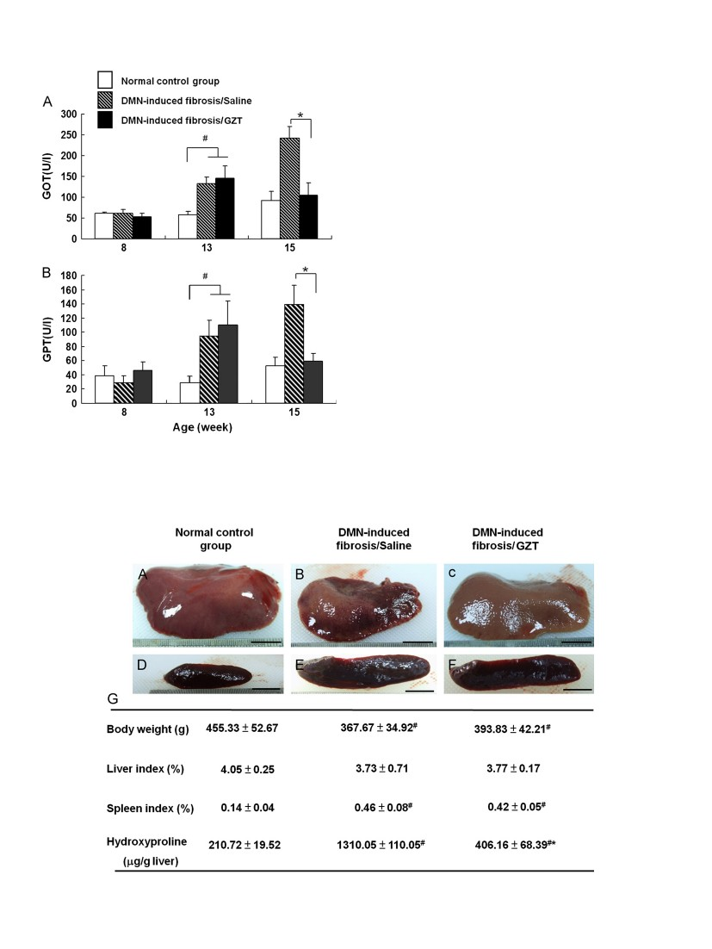
814
J.-Y. Chen et al. / Journal of Ethnopharmacology 142 (2012) 811–818
3. Results
3.1. The effects of GZT on rats with DMN-induced liver ﬁbrosis
The serum concentrations of GOT and GPT were signiﬁcantly
increased after 5 weeks of DMN treatment compared with
untreated control 13-week-old rats (p o 0.01). After hepatic
injury, the administration of GZT for 2 continuous weeks signiﬁ-
cantly decreased serum GOT and GPT levels compared to the
DMN-treated group (p o0 .01) (Fig. 3). Eight weeks after the
initiation of DMN injections, rat liver ﬁbrosis was evaluated based
on several parameters including of body weight, liver index,
spleen index and hydroxyproline, as shown in Fig. 4. The body
weight in the DMN-treated group decreased approximately 19%
compared with the control group (p o 0.01). The body weight of
the GZT-treated group was slightly greater than the DMN-treated
group, but this difference was not statistically signiﬁcant. The liver
index for the DMN-treated group decreased. Treatment with GZT
did not signiﬁcantly recover the liver index. The spleen index in
the DMN-treated group increased by 229% compared with the
control group. The abnormal spleen morphology induced by DMN
treatment was effectively reduced by GZT administration. The
major constituent amino acid of collagen is proline. Proline is
converted to hydroxyproline. To evaluate the extracellular matrix
(ECM) production, we measured hydroxyproline content. The
hepatic hydroxyproline content in the DMN-treated group
increased sevenfold over the untreated control group (p o 0.01).
However, the hydroxyproline concentration decreased in the
DMN-treated, DMN-induced group (Fig. 4G).
Fig. 3. GZT prevents DMN-induced liver ﬁbrosis as determined by serum GOT and
GPT levels. Serum GOT (A) and GPT (B) were measured in 8-, 13- and 15-week-old
rats in different groups (normal control group, white bars; DMN-induced ﬁbrosis/
saline group, ﬁlled bars; DMN-induced ﬁbrosis/GZT-treated group, black bars).
Data are expressed as the means7 SD (n¼6), #p o 0 .01 compared with normal
control group. *p o 0.01 compared with DMN-induced ﬁbrosis/saline group.
3.2. Ultrasound imaging and histological changes
The liver is a soft, multi-lobed organ, located in the right and
left upper quadrants of the abdominal cavity that accounts for
approximately 4–6% of the total body weight. The liver is divided
Fig. 4. Effect of GZT on morphology, body weight, liver index, spleen index and hydroxyproline changes in DMN-induced ﬁbrotic rats. Gross observations of liver and
spleen morphologies were performed in the normal control group (A and D), DMN-induced ﬁbrosis/saline group (B and E) and DMN-induced ﬁbrosis/GZT-treated group
(C and F) Scale bar ¼10 mm. (G) Effects of GZT treatment on body weight, liver index, spleen index and hydroxyproline of DMN-induced liver ﬁbrosis in rats. Data are
expressed as the means7 SD (n¼ 6); #p o 0.01 compared with normal control group. *p o 0.01 compared with DMN-induced ﬁbrosis/saline group.
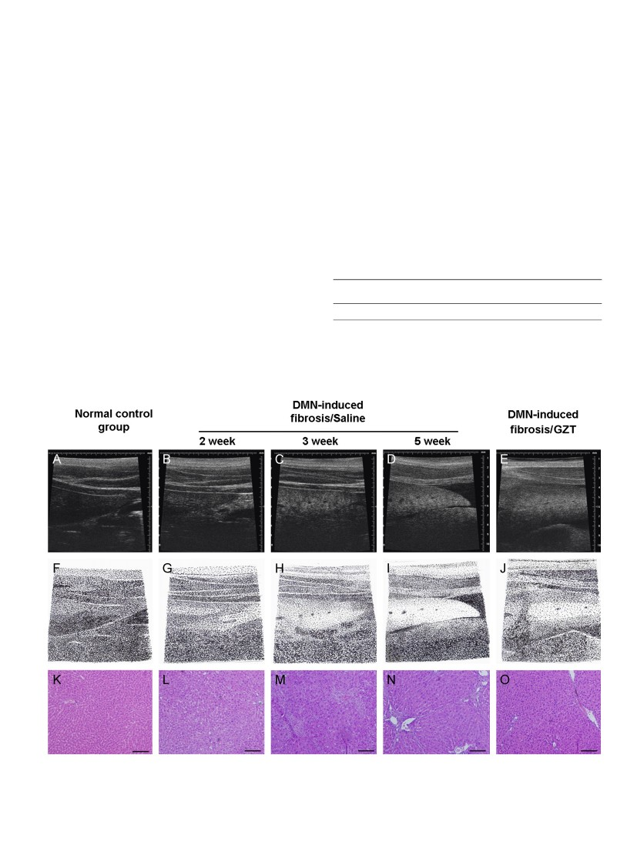
J.-Y. Chen et al. / Journal of Ethnopharmacology 142 (2012) 811–818
815
based on surface features. There are four major lobes: the median
lobe, the right lobe, the left lobe and the caudate lobe. Using
ultrasound, we determined that the left lobe liver (LLL) was a
good landmark to monitor liver ﬁbrosis progression (Chen et al.,
2012). We examined the hepatic ﬁbrosis that developed after
5 weeks of DMN treatment. A transverse ultrasound scan through
the liver showed consolidation and well-deﬁned LLL. This ﬁnding
was considered to be positive (Fig. 5A and F) for evaluating
whether DMN induced liver hepatocyte injury. We performed
ultrasound imaging at various times after DMN induced liver
injury. The ultrasound imaging showed a straight and regular
hyperechoic line. The hepatic surface appeared as a dotted or
irregular line and the liver parenchyma was heterogeneous. The
hepatic surface was dotted after 2 weeks (Fig. 5B and G) and the
hepatocytes showed an increased heterogeneous echotexture
after 3 weeks (Fig. 5C and H). The percentage of heterogeneous
echotexture increased after 5 weeks (Fig. 5D and I), and ascites
were detected. The GZT-treated livers (Fig. 5E and J) showed a
homogeneous echotexture after 5 weeks of DMN injury. A com-
parison of H&E-stained tissue sections is shown (Fig. 5K–O). The
liver tissue from DMN-treated rats had steatosis, ﬁbrosis and
degenerative hepatocytes. Notice the sharp demarcation between
central vena ﬁbrosis and surrounding liver parenchyma shown in
Fig. 5D, I and N. The ultrasound imaging was assessed by a liver
ﬁbrosis scoring system (Table S1). The total score for the DMN-
induced ﬁbrosis livers was 6.33. The GZT therapy reduced the
liver score to 3.83 (Table 1).
3.3. Effect of GZT on gene expression of collagen alpha-1(I) and
alpha-SMA
The extent of liver ﬁbrosis depends on the rates of hepatic
collagen synthesis and degradation. Gene expression for the hepatic
ﬁbrosis factors collagen alpha-1(I) and alpha-SMA was analyzed using
RT-PCR (Fig. 6). The mRNA levels of collagen alpha-1(I) and alpha-SMA
were increased in the DMN-treated group by 3.6- and 3.2-fold,
respectively, compared with the normal control group (p o 0.01).
The GZT treatment signiﬁcantly reduced the mRNA levels of collagen
alpha-1(I) and alpha-SMA by 45% and 53%, respectively (p o 0.05).
3.4. GZT induces LX-2 hepatic stellate cell line apoptosis
LX-2 cells were incubated with various concentrations of GZT.
The treatment showed that GZT inhibited the proliferation of HSCs in
Table 1
The ultrasound characteristics of different stages of total score.
Normal control
group
Total score (n¼6)
0
DMN-induced
ﬁbrosis/saline
6.33 7 0.81a
DMN-induced
ﬁbrosis/GZT
3.83 7 0.93b
The data are expressed as means 7 SD (n¼6).
a #
b
p o 0.01 compared with normal control group.
*p o 0.01 compared with DMN-induced ﬁbrosis/saline group.
Fig. 5. High-frequency ultrasonographic (HFU) imaging of GZT in DMN-induced liver ﬁbrosis. (A) An ultrasonographic image of a normal control (NC) rat left lateral lobe
(LLL). The ultrasonographic images of a rat LLL after 2 weeks (B), 3 weeks, and (C) 5 weeks of DMN treatment. (E) An ultrasonographic image of a rat LLL after 5 weeks of
DMN treatment and 2 weeks of GZT therapy. (F–J) The schematic diagrams of representative HFU images (A–E), respectively. (K–O) The hematoxylin–eosin staining of liver
histological sections corresponding to HFU images (A–E), respectively. Scale bar ¼100 mm.
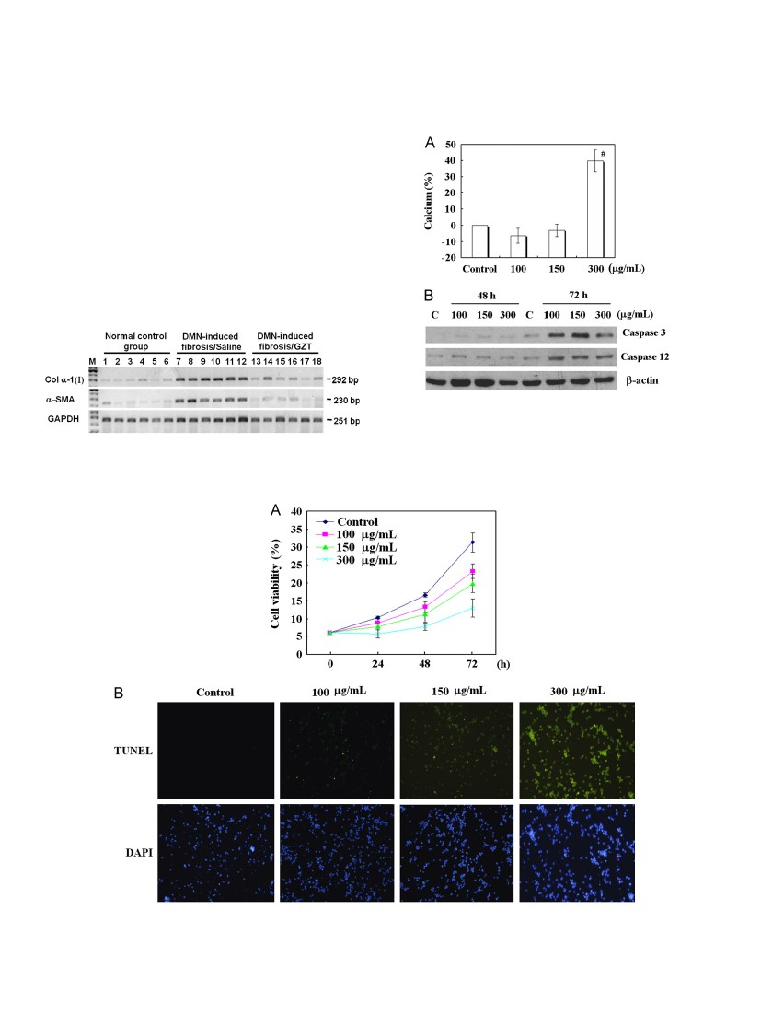
816
J.-Y. Chen et al. / Journal of Ethnopharmacology 142 (2012) 811–818
a dose- and time-dependent manner (Fig. 7A). After 72 h of incuba-
tion with GZT, the viability of the LX-2 cell line was signiﬁcantly
reduced using a TUNEL assay (Fig. 7B). The apoptotic index was
deﬁned by the percentage of cells with green ﬂuorescent signal.
The apoptotic index after 72 h was 0% for the control LX-2 cells.
However, the apoptotic index values were 8%, 17% and 82% for cells
treated with GZT at the concentrations of 100, 150, and 300 mg/mL,
respectively. These results indicate that GZT induces LX-2 cell
apoptosis in a dose-dependent manner.
3.5. GZT enhances calcium and induces LX-2 cell apoptosis through a
caspase-dependent pathway
LX-2 cells were treated with various concentrations of GZT,
and the cytosolic concentration of calcium, caspases 3 and 12
was measured. By staining the cells with Fluo-4/AM followed by
ﬂow-cytometry analysis, we found that GZT caused an increase in
the concentration of cytosolic calcium in a high dose condition
(300 mg/mL) after 6 h (Fig. 8A). To verify that GZT-induced
apoptotic death in LX-2 cells, a Western blot analysis of caspases
3 and 12 was performed. Results indicate that the protein expressions
Fig. 6. Changes in the mRNA expression levels of collagen alpha-1(I) and alpha-
SMA in the DMN-induced ﬁbrosis/saline group and DMN-induced ﬁbrosis/GZT
group. The transcription levels of collagen alpha-1(I) and alpha-SMA genes were
normalized by an internal control of GAPDH mRNA.
Fig. 8. GZT enhances calcium release, and caspase 3 and caspase 12 expression.
(A) Intracellular calcium level in LX-2 cells. Dose-dependent GZT-induced increase
in Ca2 þ level in LX-2 cells. LX-2 cells were incubated in medium containing ﬂuo-4 at
37 1C for 6 h. The concentration of Ca2 þ increased in the cytosol with 300 mg/mL after
6 h. (B) LX-2 cells were incubated in the presence and absence of GZT for 48 h or 72 h.
The cells were fractionated into a cytosolic fraction. The cytosolic fraction was
separated by SDS-polyacrylamide gel electrophoresis, and the caspases 3 and 12 were
analyzed by Western blot.
Fig. 7. GZT exhibits potent antiﬁbrosis activity on LX-2 cells. (A) LX-2 cells were seeded onto 96-well plates and the various concentrations of GZT were added to the
medium for 24, 48 and 72 h. Cell viability was measured. The data are represented as the means 7 SD (n¼ 3). (B) Representative photographs of LX-2 cells that were treated
with the various concentrations of GZT for 72 h. The determination of apoptosis was performed by a TUNEL assay with the apoptotic cells marked by green ﬂuorescence.
Nuclei were counter-stained using DAPI (blue).
J.-Y. Chen et al. / Journal of Ethnopharmacology 142 (2012) 811–818
817
of caspases 3 and 12 were signiﬁcantly increased after 72 h
treatment of GZT (Fig. 8B).
4. Discussion
Traditional Chinese medicine has been widely used in China
and Taiwan for thousands of years. Recently, many researchers
have been focused on the anti-ﬁbrosis properties of herb medi-
cines (Li et al., 2004). GZT is an effective treatment used in chronic
liver diseases including ﬁbrosis and cirrhosis. Liver ﬁbrosis is
believed to be reduced though the apoptosis of activated HSCs
and the degradation of ECM protein (Elsharkawy et al., 2005). The
effect of GZT on HSCs has been assessed by in vitro assays using
cells activated during culture and by in vivo assays using an
animal model. The present study demonstrated for the ﬁrst time
that GZT treatment is an effective therapy for treating hepatic
ﬁbrosis and HSCs activation.
DMN is a hepatotoxin and is a known cause of acute liver
injury in laboratory animals. The DMN-induced liver ﬁbrosis
model recreates the features observed during the progression of
human liver ﬁbrosis (Jezequel et al., 1987). The DMN-damaged
livers were reduced in size and contained dark discolorations. The
decreased liver size was caused by congestion (Fig. 4B), which is
consistent with clinical liver disease patients. Using an animal
model, DMN has been shown to damage endothelial cells and
cause cell morphological changes in adjacent hepatocytes
(Fig. 5L–N). The liver ﬁbrosis and DMN-induced histopathological
deterioration of liver tissue was improved by feeding animals a
diet containing 1.8 g/kg GZT. Following HPLC, paeoniﬂorin and
glycyrrhizin were isolated and identiﬁed from the GZT mixture
(Fig. 1). Previous studies have shown that paeoniﬂorin, an active
component of Paeonia lactiﬂora, inhibits the activity of LPS-
induced liver inﬂammatory reactions (Kim and Ha, 2010; Gan
et al., 2012). Glycyrrhizin is a triterpenoid saponin glycoside of
glycyrrhizic acid. Glycyrrhizin can inhibit the liver cell injury
caused by many chemicals (Pompei et al., 1979) and also exhibit
cardioprotective effects against isoproterenol-induced myocardial
ischemia in rats (Haleagrahara et al., 2011). Therefore, it is possible
that the improvement of mortality and liver ﬁbrosis resulted from
the hepatoprotective effects of these natural compounds.
The extent of liver ﬁbrosis was decreased after GZT adminis-
tration. Treatment with GZT decreased the serum GOT and GPT
activity (Fig. 3), suggesting that such improvement may result
from the attenuation of hepatocyte necrosis. Treatment with GZT
also signiﬁcantly relieved the DMN-induced histopathological
deterioration and hydroxyproline concentration in liver tissue.
However, GZT did not affect the spleen index, liver index or body
weight (Fig. 4).
We performed in vivo assays to show a timeline of DMN-
induced liver ﬁbrosis using serial imaging analysis. A live ultra-
sound image can detect and monitor liver ﬁbrosis in real time.
Recent studies have shown a correlation between ultrasound
imaging and chronic liver injury (Chen et al., 2012). Our study
extensively expands this concept by demonstrating a role for GZT
in liver ﬁbrosis using ultrasound imaging. Our results show the
ultrasonographic signs of liver ﬁbrosis using a scoring system.
Additionally, we used the pathological distribution of ﬁbrosis
with the imaging analysis (Chen et al., 2012). Ultrasound imaging
reveals that the administration of GZT has a hepatoprotective
effect in DMN-induced liver ﬁbrosis.
Hydroxyproline is a major constituent of collagen and is a
marker of ECM accumulation (Lin et al., 2011a, b; Wang et al.,
2011). Our studies demonstrate that GZT reduced hydroxyproline
levels in liver tissue. The mechanism of GZT action may be due to
the improved sinusoidal clearance of hydroxyproline because of
decreased ﬁbrosis. It is also possible that GZT has inhibitory
effects on stellate cell activation. In addition, GZT prevented the
accumulation of collagen proteins, presumably by inhibiting the
activation of stellate cells. Reducing the activation of stellate cells
decreased the expression of collagen alpha-1(I) and alpha-SMA
mRNA (Fig. 6) in proportion to the reduced production of
collagens and stellate cell activity. This result is consistent with
results obtained by Lin et al., 2011a, b that showed Yi Guan Jian
(YGJ) reduced collagen deposition in the DMN model of hepatic
ﬁbrosis. The reduced ﬁbrosis was associated with reduced alpha-
SMA expression and type I procollagen expression in the liver.
Furthermore, clinical studies and experimental models have
demonstrated an association between the apoptosis of stellate
cells and a regression of ﬁbrosis (Elsharkawy et al., 2010).
In this study, we demonstrated that GZT could stimulate
an increase of intracellular calcium in a high dose condition
(300 mg/mL; Fig. 8A). In addition, GZT treatment induced LX-2
cell apoptosis and permeability defects (Fig. 7). Furthermore,
caspase activation is a critical event in apoptotic cell death. We
demonstrated that GZT induced LX-2 apoptosis, which was
caused by enhanced caspases 3 and 12 expression (Fig. 8B). This
study provides the ﬁrst evidence that GZT induces LX-2 cell
apoptosis though extracellular Ca2 þ inﬂux and the increasing
caspases 3 and 12 expression. The activation of caspases can
trigger a caspase-dependent endoplasmic reticulum (ER) apopto-
sis pathway. Crosstalk between the ER and the mitochondria can
initiate apoptosis. We could speculate that in GZT-treated HSCs,
the ER plays an important role in the storage of Ca2 þ to regulate
intracellular Ca2 þ homeostasis. Treatment with GZT could cause a
leak of calcium stores from the ER and can therapy lead to the
activation of caspase 12. Caspase 12 activation can then activate
caspase 3, leading to HSC apoptosis. Thus, we found that GZT
exposure increased caspase 12 expression in a dose-related
manner for 72 h, suggesting that the ER pathway may play a role
in GZT-induced apoptosis.
In conclusion, the results presented here show that GZT was
effective in mitigating DMN-induced liver ﬁbrosis in rats. The
primary mechanism of this therapeutic effect could be protection
against hepatic injury via reduced activation of HSCs. The GZT
induced HSC apoptosis because of increased expression of cas-
pases 3 and 12. Therefore, this study suggests that GZT may be
useful in preventing the development of hepatic ﬁbrosis. In future
studies, we will investigate the hepatic cirrhosis animal model
and perform genomic and epigenetic analysis after herb medicine
therapy.
Appendix A. Supporting information
Supplementary data associated with this article can be found in
the online version at http://dx.doi.org/10.1016/j.jep.2012.06.005.
References
Bataller, R., Brenner, D.A., 2005. Liver ﬁbrosis. The Journal of Clinical Investigation
115, 209–218.
Chen, C.M., Chen, H.L., Hsiau, T.H., Hsiau, A.H., Shi, H., Brock, G.J., Wei, S.H.,
Caldwell, C.W., Yan, P.S., Huang, T.H., 2003. Methylation target array for rapid
analysis of CpG island hypermethylation in multiple tissue genomes. The
American Journal of Pathology 163, 37–45.
Chen, H.L., Huang, J.Y., Chu, T.W., Tsai, T.C., Hung, C.M., Lin, C.C., Liu, F.C., Wang, L.C.,
Chen, Y.J., Lin, M.F., Chen, C.M., 2008a. Expression of VP1 protein in the milk of
transgenic mice: as a potential oral vaccine protects against enterovirus 71
infection. Vaccine 26, 2882–2889.
Chen, H.L., Wang, L.C., Chang, C.H., Yen, C.C., Cheng, W.T., Wu, S.C., Hung, C.M.,
Kuo, M.F., Chen, C.M., 2008b. Recombinant porcine lactoferrin expressed in the
milk of transgenic mice protects neonatal mice from a lethal challenge with
enterovirus type 71. Vaccine 26, 891–898.
818
J.-Y. Chen et al. / Journal of Ethnopharmacology 142 (2012) 811–818
Chen, H.L., Lai, Y.W., Chen, C.S., Chu, T.W., Lin, W., Yen, C.C., Lin, M.F., Tu, M.Y.,
Chen, C.M., 2010. Probiotic Lactobacillus casei expressing human lactoferrin
elevates antibacterial activity in the gastrointestinal tract. BioMetals 23,
543–554.
Chen, J.Y., Chen, H.L., Wu, S.H., Tsai, T.C., Lin, M.F., Yen, C.C., Hsu, W.H., Chen, W.,
Chen, C.M., 2012. Application of high-frequency ultrasound for the detection
of surgical anatomy in the rodent abdomen. The Veterinary Journal 191,
246–252.
Chen, Y.J., Wu, C.Y., Chang, C.C., Ma, C.J., Li, M.C., Chen, C.M., 2008c. Nuclear
Kruppel-like factor 4 expression is associated with human skin squamous cell
carcinoma progression and metastasis. Cancer Biology and Therapy 7,
777–782.
Chen, Y.J., Wu, C.Y., Shen, J.L., Chu, S.Y., Chen, C.K., Chang, Y.T., Chen, C.M., 2008d.
Psoriasis independently associated with hyperleptinemia contributing to
metabolic syndrome. Archives of Dermatology 144, 1571–1575.
Elsharkawy, A.M., Oakley, F., Mann, D.A., 2005. The role and regulation of hepatic
stellate cell apoptosis in reversal of liver ﬁbrosis. Apoptosis 10, 927–939.
Elsharkawy, A.M., Oakley, F., Lin, F., Packham, G., Mann, D.A., Mann, J., 2010. The
NF-kappaB p50:p50:HDAC-1 repressor complex orchestrates transcriptional
inhibition of multiple pro-inﬂammatory genes. Journal of Hepatology 53,
519–527.
Friedman, S.L., 2003. Liver ﬁbrosis—from bench to bedside. Journal of Hepatology
38, S38–53.
Gan, P., Zhong, M., Huang, X., Sun, M., Wang, Y., Xiao, Y., Zeng, C., Yuan, Q., Liu, Z.,
Zhou, H., 2012. Pharmacokinetic comparisons of albiﬂorin and paeoniﬂorin
after oral administration of shaoyao-gancao-tang and single herb paeony
decoction to rats. Planta Medica 78, 237–243.
Ge, Z.Y., Lin, C.R., Zhou, Y.W., 1994. Study of platelet aggregation affected by
8 classical recipes in rabbit. Zhongguo Zhong Xi Yi Jie He Za Zhi 14, 489–490.
Haleagrahara, N., Varkkey, J., Chakravarthi, S., 2011. Cardioprotective effects of
glycyrrhizic acid against isoproterenol-induced myocardial ischemia in rats.
International Journal of Molecular Sciences 12, 7100–7113.
Hu, J., Zhang, J., Zhao, W., 2011. Cochrane systematic reviews of Chinese herbal
medicines: an overview. PLoS One 6, e28696.
Hung, C.M., Yeh, C.C., Chen, H.L., Lai, C.W., Kuo, M.F., Yeh, M.H., Lin, W., Tu, M.Y.,
Cheng, H.C., Chen, C.M., 2010. Porcine lactoferrin administration enhances
peripheral lymphocyte proliferation and assists infectious bursal disease
vaccination in native chickens. Vaccine 28, 2895–2902.
Hung, C.M., Yeh, C.C., Chong, K.Y., Chen, H.L., Chen, J.Y., Kao, S.T., Yen, C.C., Yeh, M.H.,
Lin, M.S., Chen, C.M., 2011. Gingyo-San enhances immunity and potentiates
infectious bursal disease vaccination. Evidence-based Complementary and Alter-
native Medicine, 238208.
Jamall, I.S., Finelli, V.N., Que Hee, S.S., 1981. A simple method to determine
nanogram levels of 4-hydroxyproline in biological tissues. Analytical Biochem-
istry 112, 70–75.
Jezequel, A.M., Mancini, R., Rinaldesi, M.L., Macarri, G., Venturini, C., Orlandi, F.,
1987. A morphological study of the early stages of hepatic ﬁbrosis induced by
low doses of dimethylnitrosamine in the rat. Journal of Hepatology 5,
174–181.
Kim, I.D., Ha, B.J., 2010. The effects of paeoniﬂorin on LPS-induced liver inﬂam-
matory reactions. Archives of Pharmacal Research 33, 959–966.
Li, W.L., Zheng, H.C., Bukuru, J., De Kimpe, N., 2004. Natural medicines used in the
traditional Chinese medical system for therapy of diabetes mellitus. Journal of
Ethnopharmacology 92, 1–21.
Lin, H.J., Tseng, C.P., Lin, C.F., Liao, M.H., Chen, C.M., Kao, S.T., Cheng, J.C., 2011a. A
Chinese herbal decoction, modiﬁed Yi Guan Jian, induces apoptosis in hepatic
stellate cells through an ROS-mediated mitochondrial/caspase pathway. Evi-
dence-based Complementary and Alternative Medicine 459531.
Lin, H.J., Chen, J.Y., Lin, C.F., Kao, S.T., Cheng, J.C., Chen, H.L., Chen, C.M., 2011b.
Hepatoprotective effects of Yi Guan Jian, an herbal medicine, in rats with
dimethylnitrosamine-induced liver ﬁbrosis. Journal of Ethnopharmacology
134, 953–960.
Liu, F.C., Chen, H.L., Chong, K.Y., Hsu, A.L., Chen, C.M., 2008. Production of
recombinant porcine colipase secreted by Pichia pastoris and its application
to improve dietary fat digestion and growth of postweaning piglets. Biotech-
nology Progress 24, 1333–1341.
Pompei, R., Flore, O., Marccialis, M.A., Pani, A., Loddo, B., 1979. Glycyrrhizic acid
inhibits virus growth and inactivates virus particles. Nature 281, 689–690.
She, S.F., Huang, X.Z., Tong, G.D., 2004. Clinical study on treatment of liver ﬁbrosis
by different dosages of Salvia injection. Zhongguo Zhong Xi Yi Jie He Za Zhi 24,
17–20.
Tsai, T.C., Lin, W., Yang, S.H., Cheng, W.T., Cheng, E.H., Lee, M.S., Chong, K.Y., Chen,
C.M., 2010. Granzyme G is expressed in the two-cell stage mouse embryo and
is required for the maternal-zygotic transition. BMC. Developmental Biology
10, e88.
Tsukada, S., Parsons, C.J., Rippe, R.A., 2006. Mechanisms of liver ﬁbrosis. Clinica
Chimica Acta 364, 3–60.
Tung, Y.T., Chen, H.L., Lai, C.W., Shen, C.J., Lai, Y.W., Chen, C.M., 2011. Curcumin
reduces pulmonary tumorigenesis in vascular endothelial growth factor
(VEGF)-overexpressing transgenic mice. Molecular Nutrition and Food
Research 55, 1036–1043.
Wang, T., Zhao, L.J., Li, P., Jiang, H., Lu, G.C., Zhang, W.D., Li, H.L., Yuan, B.J., 2011.
Hepatoprotective effects and mechanisms of dehydrocavidine in rats with
carbon tetrachloride-induced hepatic ﬁbrosis. Journal of Ethnopharmacology
138, 76–84.
Wang, Q.R., 2007. Ge Xia Zhu Yu Tang. Yi Lin Gai Cuo: Correcting the Errors in the
Forest of Medicine. Blue Poppy Enterprises Inc. pp. 500.
Wu, S.C., Chen, H.L., Yen, C.C., Kuo, M.F., Yang, T.S., Wang, S.R., Weng, C.N., Chen,
C.M., Cheng, W.T., 2007. Recombinant porcine lactoferrin expressed in the
milk of transgenic mice enhances offspring growth performance. Journal of
Agricultural and Food Chemistry 55, 4670–4677.
Yen, C.C., Lin, C.Y., Chong, K.Y., Tsai, T.C., Shen, C.J., Lin, M.F., Su, C.Y., Chen, H.L.,
Chen, C.M., 2009. Lactoferrin as a natural regimen of selective decontamina-
tion of the digestive tract: recombinant porcine lactoferrin expressed in the
milk of transgenic mice protects neonates from pathogen challenges in the
gastrointestinal tract. Journal of Infectious Diseases 199, 590–598.
Yen, C.C., Lai, Y.W., Chen, H.L, Lai, C.W., Lin, C.Y., Chen, W., Kuan, Y.P., Hsu, W.H.,
Chen, C.M., 2011. Aerosolized human extracellular superoxide dismutase
prevents hyperoxia-induced lung injury. PLoS One 6, e26870.

