Applying Situated Learning in a Virtual Reality System to Enhance Learning Motivation
Huang HsiuMei and Liaw ShuSheng
 
 
Abstract—In human anatomy courses, computing, networking and virtual reality technologies provide useful tools to help overcome the limitations of two-dimensional course materials. For situated learning, knowledge resides in the learning environment. Learners construct knowledge or acquire skills through participating in activities as well as through actively interacting with and exploring objects and phenomena inside the learning environment. In this study, a Virtual Hospital Situated Learning System (VHSLS) uses virtual reality to develop a virtual learning environment focused on human organ anatomy. The results explained that VR features and perceived usefulness variables were predictors for situated learning. Moreover,the results are found to be statistically significant and indicate that situated learning helps to improve the motivation to learn.
Index Terms—Virtual Reality (VR), situated learning, learning motivation, body organs
I. INTRODUCTION Many educational applications have successfully employed virtual reality learning environments [1]-[3], and desktop virtual reality applications have become popular in classroom education. Virtual reality (VR) allows the visualization of three dimensional (3D) data and provides interactive environments that reinforce the sensation of immersion into a computer-generated virtual world. In addition, VR provides learners with a realistic simulated environment in which to safely perform specific tasks. While VR offers real time simulation, three-dimensional computer graphics are used to mimic the real world [4].Various research on educational technologies indicate that 3D virtual reality and network technologies raise learner motivation, enhance learner attitudes towards learning and improve learning efficiency. Moreover, these technologies can be used to inexpensively construct specialized learning environments for individual courses, which are conducive to improving learner motivation and performance. This can be especially helpful in disciplines for which realistic learning environments cannot be provided in a traditional classroom.
Human anatomy is one of the most important foundation disciplines in medical education, but information conveyed
Manuscript received 0ctober 14, 2011; revised 0ctober 30, 2011. This study was supported in part by Taiwan National Science Council under Grant NSC99-2511-S-025-001 and NSC100-2511-S-025-003-MY3.
H. M. Huang is with the Department of Information Management, National Taichung Institute of Technology, Taiwan (e-mail: hmhuang@ntit.edu.tw).
S. S. Liaw is with the Department of General Education, China Medical University, Taiwan (e-mail:ssliaw@mail.cmu.edu.tw).
by 2D human anatomy course materials cannot accurate approximate the 3D reality. A flat image of an organ cannot show the relative positions among organs in the direction of missing dimension, and the instructional effectiveness of 2D course materials is limited. As a result, specimens, plastinated organs, or artificial anatomical models are needed to complement the course curriculum.
Virtual reality technologies allow people to visualize and interact with computer-generated 3D objects (e.g., body organs), potentially providing a safe and inexpensive means to create an immersive, interactive virtual environment conducive to effective and engaging learning [3]. Virtual reality allows individual students to each have a complete set of simulated organs and a private space in which to study them. 3D objects mimic real world objects, and these can be made part of real-time simulations through VR technologies [5], allowing learners to experience a synthetic reality [6]. This type of simulation also has the important benefit of allowing novice trainees to develop clinical skills without requiring contact with real patients. Virtual learning environments are not only cheaper to build but are also safer and potentially more flexible. Several learning systems have successfully developed effective virtual learning environments [1], [3], and 3D organ models, presented in conjunction with lectures, can improve the learning outcomes for medical students. Successful immersion in a VR world is based on the degree of learner involvement [8], and educators seek to take advantage of the immersion of VR to raise learner intention to engage in learning activities [7].
In this research, we designed and built a virtual hospital situated learning system (VHSLS) to help medical students develop knowledge of human organs. The system demonstrates a potential deployment of virtual reality and current 3D technologies to implement an inexpensive learning environment in medical education. This paper first presents background information regarding features of virtual learning environments before reviewing theories of situated learning and learner motivation. The system architecture and features are then presented, followed by a description of the system functions, illustrated with screenshots. Finally, we evaluate the effectiveness of the VHSLS system and conclude with a brief summary.
II. A REVIEW OF LITERATURE
A. Features of Virtual Reality
Virtual reality includes the three factors: immersion, interaction, imagination [5]. Virtual reality (VR) refers to the use of 3D graphic systems used in combination with various interface devices to provide the effect of immersion in the

interactive virtual environment [3], and success in immersion is measured by the us
er
‟
s level of involvement [8]. The
immersion of VR presents educators with opportunities to engage the attention of learners in learning activities [7].

Real-time interactivity is another important feature of virtual reality. 3D systems provide learners with an interactive interface, allowing them to become more effectively engaged with the learning system. The visual, auditory, or haptic devices that establish the physical sensations associated with immersion in the scene change in response to user activity [8]. Thus, learners see the surrounding environment transformed by their activity, using physical sensation to access the interactive functions. Virtual reality not only provides an immersive user interface, but is also used to effectively present objects in many fields such as engineering, medicine, and education. A VR learning environment could expand the human mind's capacity to perceive and creatively imagine nonexistent things.

B. Situated Learning
Knowledge must be presented in authentic settings and relevant situations to be properly understood. Social interaction and collaboration are essential components of situated learning. For effective knowledge acquisition, the learning context is expected to construct an instructional environment sensitive to the tasks learners must complete to be successful in practice. The learning context can include experiences of engaging with and interacting in the social, psychological, and material environment in which the learner is situated. Content situated in the learner's daily experience becomes the means by which to engage in reflective thinking. Retention of content is not the goal of learning. Rather, by placing content within the context of daily transactions, the instructor, in dialogue with learners, negotiates the meaning of content, frames it in terms of the issues and concerns the learners face, provides opportunities for learners to cooperate in investigating problems, and makes content applicable to the ways in which learners will approach the environment.
Many educators exploring the model of situated learning have accepted that computer technology can provide an alternative to real-life settings. For example, virtual reality simulations enable learners engage in learning in a realistic-looking environment. VR offers richer perceptual cues and multimodal feedback (e.g., visual, auditory, haptic, etc.) to enable the easy transfer of VR-based learning into real-world skills [9].
According to Herrington and Oliver [4] situated learning environments should:
- provide authentic contexts that reflect the way the knowledge will be used in real-life;
- provide authentic activities;
- provide access to expert performances and the modelling of processes;
- provide multiple roles and perspectives;
- support the collaborative construction of knowledge;
- provide coaching and scaffolding at critical times;
- promote reflection to enable the formation of abstractions;
- promote articulation to enable tacit knowledge to be made explicit; and

• provide for integrated assessment of learning within the tasks. In short, virtual reality and situated learning characteristics have been developed to support learning and teaching in technology-rich learning environments. Scaffolding
enhanced by VR technology may help students to identify authentic, situated problems during their leaning processes.
C. Motivation Theory
Motivation has been generally defined as an internal state or condition that activates guides, maintains or directs behavior [11]. Motivation can be classified as intrinsic or extrinsic. Intrinsic motivation refers to doing an activity because doing so is enjoyable and satisfying [12]. Learners are intrinsically motivated when their needs are directly satisfied, and are willing to learn if they perceive the learning process to be internally satisfying. Extrinsic motivation refers to those actions implemented to achieve some intended goals [12]. Extrinsic motivations include pursuit of personal benefits (e.g., high test scores) or social benefits (e.g., peer acceptance). Therefore, learners can be guided by the pursuit of an external outcome that is separable from the learning activity.
The learning environment should be considered as a significant motivating factor for situated learning [13]. Dewey [14] believed that students should learn in authentic situations, and that learning by doing improves skills through practice on realistic tasks. Social cognition theory holds that motivation is not only influenced by an individual's behavior but also varies depending on the situated learning environment and context of learning. Students have been shown to be motivated by the realistic scenes, dynamic presence and high interaction supported by VR [15]. Virtual reality allows learners to engage in learning in a simulated environment. Thus, VR technology aims to turn a learning situation into an engaging learning environment in which learners attempt to solve authentic problems. In addition, it is important to support learner commitment to the relevant learning processes and also to motivate them by means of situational incentives or learning results. Thus, knowledge acquisition is based on active experience.
III. THE VIRTUAL REALITY TEACHING HOSPITAL A virtual hospital situated learning system (VHSLS) was built to provide an immersive, situated learning environment for medical students. Inside the virtual hospital, learners can
navigate and explore the scene, study course topics and interact with 3D objects.
A. Design of VHSLS
VHSLS was designed using Virtools 4.0. 2D video was generated in Flash and then imported into ActionScript. 3D graphic modules were then drawn and rendered by using 3DsMax. The design of VHSLS system follows the object oriented programming paradigm. Figure 1 presents the VHSLS architecture.
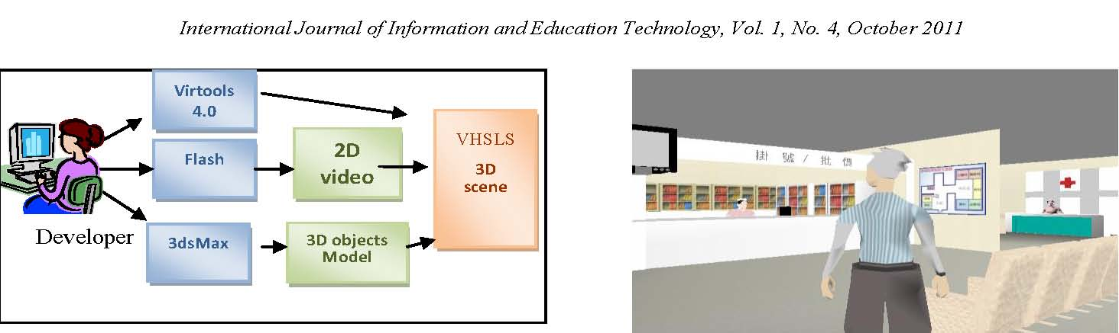
Fig. 1. VHSLS architecture.
B. Functions and Features
The VHSLS‟s 3D components were provided by the Turbo Squid Company. 3D graphic modules are rendered and animated using 3DsMax and Flash. To provide greater interactivity and enable multiple-angle observation, considerable effort was spent on camera and character control management. Camera and character movements are related because proper viewpoints are necessary for easy and intuitive character control. VHSLS allows users to control the character from the 1st or 3rd person perspective.
In the 1st person perspective, the view camera‟s orientation and location coincide with the virtual character‟s eyes. Fig.2 and 3 show samples of the 1st person perspective. In this perspective, users can command the character to walk, run, strafe, turn and circle around a focus. By default, in the 3rd person perspective, the view camera is located somewhere near and above the character to view the character as shown in Fig. 4. Fig. 5 shows a doctor introducing diseases related to the respiratory tract. In this perspective, users can also freely move the view camera to any location and change its orientation. The view camera can also be set to circle around an object, which is particularly useful in organ observation. In addition, the learner can rotate and zoom in/out on the organ, as shown in Fig. 6.
Fig. 2. Learner interacts with the doctor.
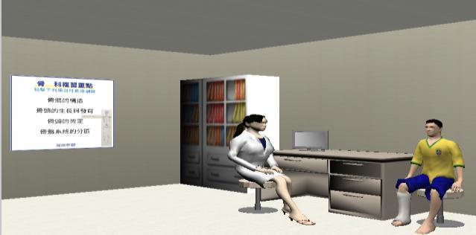
Fig. 3. Doctor introduces the patient‟s heart disease symptoms.
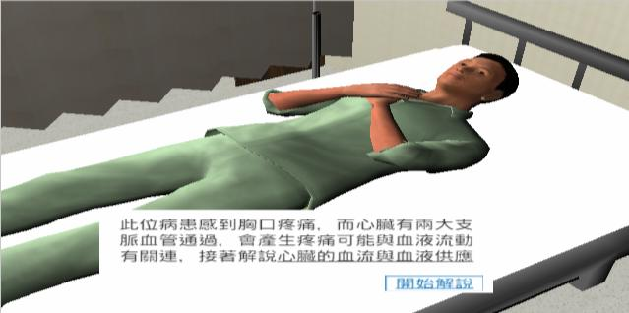
Fig. 4. VHSLS lobby.
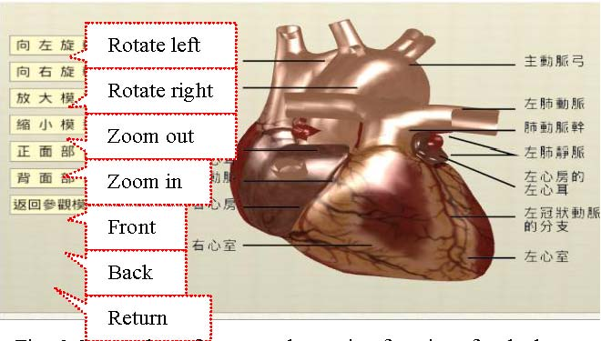
Fig. 6. Screenshot of rotate and zooming functions for the heart.
IV. EVALUATION After learners had experienced the VHSLS, their perception of the system was evaluated by questionnaire using a Likert scale ranging from 1 (strongly disagree) to 5
(strongly agree).The participants were 86 medical students in central Taiwan (31 females and 45 males), detailed in Fig. 7.
Fig. 5. Screenshot of course contents.
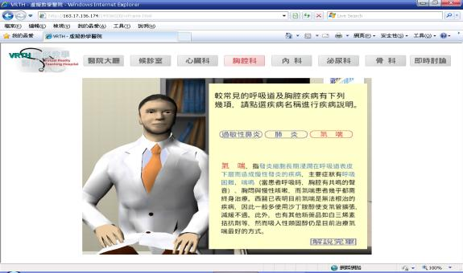
Fig. 7. Experimental participants.
System Evaluation

This research attempts to explore the relationships among VR features, perceived usefulness, situated learning and
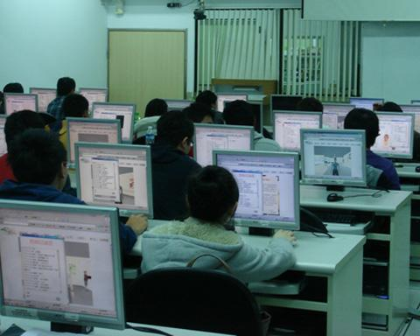

learning motivation, as shown in Fig. 8.

VR features


Situated Learning
 | 11. I feel the VHSLS scenario design is appropriate for teaching the body organs. | 3.91 | 0.77
Learning motivation | 12. VHSLS can complement traditional instruction for body organs. | 3.97 | 0.80
Learning motivation | 13. I hope that other courses can apply virtual reality learning systems to assist my learning. | 4.00 | 0.71
Learning motivation | 14. Overall, I feel VHSLS is a good learning system for body organs. | 4.22 | 0.65

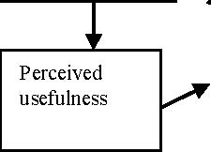
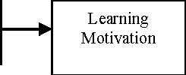
Fig. 8. Research model
B. Results
Over half (54%) of respondents indicated having previously experienced virtual reality, and 24% had experienced virtual reality applied in an educational settings, and 72.3% had previously taken anatomy courses. Results indicate that most respondents (88%) had over six years of experience in using computers.
The means and standard deviations of the four factors are shown in TABLE I. The highest mean score (M=4.33) is for Item 3, indicating that learners perceived VHSLS as being genuinely helpful to their understanding of the spatial relationships among body organs. Item 9 has the lowest mean score (M=3.29), indicating that, to be appealing to learners, the VHLS needs to develop a better quality presence, become more immersive and provide more realistic visuals. The
Cronbach's |  | α values |  |  | for | VR | features |  |  | (.85), |  |  | perceived
usefulness | (.70), |  | situated |  |  | learning |  |  | (.78) |  | and |  |  | learning
motivation | (.79) |  | all | indicate |  |  |  | acceptable |  |  |  | measurement

reliability. TABLE II shows the value of the Cronbach α coefficient evaluated for the questionnaires scores.
TABLE I: MEANS AND STANDARD DEVIATIONS FOR EACH QUESTION
Factor | Items | M. | S.D.
 | 1. I can interact with virtual objects in the VHSLS. | 4.04 | 0.68
 | 2. I can observe 3D body organs from different angles in the VHSLS. | 4.20 | 0.73
VR features | 3. VHSLS helps me to better understand spatial relationships among body organs. | 4.33 | 0.74
 | 4. VHSLS helps me to better understand the shapes of body organs. | 4.29 | 0.67
 | 5. Overall, VHSLS improves my ability to visualize body organs. | 4.22 | 0.78
 | 6. Course contents help me to review the knowledge of body organs in the VHSLS.. | 3.88 | 0.75
Perceived usefulness | 7.The representations of the course contents assist my understanding in the VHSLS. | 3.93 | 0.75
 | 8.The representations of the course contents aid memorization in the VHSLS. | 3.86 | 0.86
Situated learning | 9.The VHSLS‟s virtual scenes felt real. | 3.29 | 0.95
Situated learning | 10. I felt immersed in the virtual hospital learning environment. | 3.37 | 1.03

TABLE II : QUESTIONNAIRE CRONBACH Α COEFFICIENT VALUE
Factor | Cronbach’s α
VR features | 0.85
Perceived usefulness | 0.70
Situated learning | 0.78
Learning motivation | 0.79

Multiple regression analysis has been widely adopted for empirically examining sets of linear causal relationships. A regression analysis was conducted to check the effect of VR features on perceived usefulness. The results indicated that the VR features variable was the predictor for perceived usefulness (p=0.00, R2 =0.18), as shown in TABLE III. The learners perceived the VHSLS to be useful based on VR features such as interactive by operating surgery on 3D virtual human body organs. In addition, regression analysis was conducted to check the effect of VR features and perceived usefulness on situated learning. The results explained that VR features and perceived usefulness variables were predictors for situated learning. Perceived usefulness was the most significant contributor (18.0%) for situated learning, as shown in TABLE III. Finally, situated learning provided 18.9% of the contribution for student motivation to learn by using VHSLS.
TABLE III: REGRESSION ANALYSIS RESULT
Dependent variables | Independent Variable | R2 | F | p
Perceived usefulness | VR features | .178 | 16.053 | <0.001
Situated learning | VR features | .056 | 5.421 | =0.023
Situated learning | Perceived usefulness | .180 | 16.169 | <0.001
Learning motivation | Situated learning | .189 | 17.217 | <0.001

V. CONCLUSION VR technologies provide a way to build a low-cost alternative learning environment. This is a particular advantage in medical training in that it enables students to practice their clinical skills without exposing patients to any risk. Inexpensive VR technologies were used to build a virtual hospital situated learning system (VHSLS) was created as a sample situated learning environment in medical education. VHSLS provides immersive situated environment for students to learn human organs in a virtual hospital. This study points to three key attractions for students in the
VHSLS. First, learners can scale and rotate 3D models of organs, can actively explore the hospital or organs by

interacting with the learning system as an avatar, and can feel immersed in the virtual hospital learning environment. Through VR, a learning system can stimulate learner motivation while helping learners visualize and develop abstract concepts. Thus students perceive the VR features as being useful in learning. Secondly, VR features can also be used to create a situated learning environment, and learner perceived usefulness of VHSLS was a predictor for situated learning. Thirdly, situated learning contributes 18.9% to

enhance learners
‟
motivation, since the VHSLS allows

learners to better acquire knowledge of human organs. The results of the study support the proposition that “VR features were a significant antecedent to motivation.” [15, p.1435]
The key goal of education is to enable students to transfer their acquired knowledge into practice. Overall, learners took a positive attitude towards VHSLS. VR technology can successfully enhance the scaffolding of situated learning, and can employ several pedagogical strategies including integrating authentic tasks, maintaining common goals and motivation. The majority of participants reported increased interest and motivation for learning based on their use of the VHSLS. These results were evaluated as significant contributions and hence positively influence the use of 3D technology in virtual reality learning. This study also showed that learners have few opportunities to engage in or experience causal reasoning from 3D virtual reality learning systems.
Mobile devices are having an increased impact in education and educational applications of virtual reality can be integrated into mobile devices to result in a significant improvement over traditional instructional methods. Mobile devices offer ubiquitous access and VR technology can increase interactivity and immersion of course contents, thus providing an immersive, engaging environment which can stimulate learners‟ motivation and curiosity. Future improvements can include the development of avatars through which learners can engage in role play for collaborative and sharing learning. In addition, we believe that VR technologies can also be beneficially applied to education in other disciplines.
REFERENCE
[1] L. Chittaro, and R. Ranon, “Web3D technologies in learning, education and training: Motivations, issues, opportunities”, Computers & Education, vol.49, pp.3-18,2007.
[2] N. W. John, “The impact of Web3D technologies on medical education and training”, Computers & Education,vol.49, pp.19-31,2007.
[3] Z. Pan, A. D. Cheok, H. Yang, J. Zhu, and J. Shi, “Virtual reality and mixed reality for virtual learning environments”, Computers & Graphics,vol. 30, pp.20-28, 2006.
[4] G. C. Burdea, “Haptic Feedback for Virtual Reality”, Keynote Address of Proceedings of International Workshop on Virtual prototyping, Laval, France, pp. 87-96,1999,
[5] G. C. Burdea, and P. Coiffet, Virtual Reality Technology, New York: John Wiley & Sons, 2003.
[6] S. Mills and J. Noyes, “Virtual reality: an overview of user-related design issues revised paper of Special Issue on „Virtual reality: user Issues‟ in Interacting with Computers, May 1998”, Interacting with Computers,vol.11, pp.375-386,1999.
[7] K. Hanson, and B. E. Shelton, “Design and development of virtual reality: analysis of challenges faced by educators”. Educational Technology & Society, vol.11,no.1,118-131, 2008.
[8] W. R. Sherman,and A. B. Craig, Understanding Virtual Reality, New York: Morgan Kaufmann Publishers, 2003.
[9] N. I. Durlach, A. S. Mavor, (Eds.), Virtual Reality: Scientific and Technological Challenges, Washing D.C: National Academy Press, 1995.
[10] J. Herrington, R. Oliver.(Jan. 2011). Critical Characteristics of Situated Learning: Implications for the Instructional Design of Multimedia.[Online] Available: http://www.konstruktivismus.uni-koeln.de/didaktik/situierteslernen/he rrington.pdf.
[11] D. Schunk, “Introduction to the special section on motivation and efficacy”, Journal of Educational Psychology,vol. 82,pp. 1-6, 1990.
[12] R. M. Ryan, and E. L. Deci, “Intrinsic and extrinsic motivations: Classic definitions and new directions”, Contemporary Educational Psychology, vol.25,pp. 54 – 67, 2000.
[13] S. Järvelä, and M. Niemivirta, ―The changes in learning theory and the topicality of the recent research on motivation”, Learning and Instruction,Vol. 9, pp. 57-65,1999.
[14] J. Dewey, Democracy and education. New York: The Free Press, 1916.
[15] E. A.-L. Lee, K. W. Wong, and C.C. Fung, “How does desktop virtual reality enhance learning outcomes? A structural equation modeling approach”, Computers & Education, vol. 55, no.4, pp.1424-1442, 2010.
Huang HsiuMei is a Professor at the National Taichung Institute of Technology in Taiwan. She obtained her Ed.D. in Instructional Technology of Education at Seattle Pacific University, Seattle,

U.S.A. She received her M.S. degree in Applied Mathematics from National Chung Hsing Unversity, and B.S. degree in Computer Science from Soochow University in Taiwan. Dr. Huang‟s research interests,
are in e-learning electronic commerce, and Virtual Reality learning. Her works has appeared in such Journals as Computers & Education, British Journal of Educational Technology, Computers in Human Behaviors, Educational Technology, International Journal of Instructional Media, Information Systems Management, and Pattern Recognition.
Liaw ShuSheng is Professor at the China Medical University, Taiwan. His current research interests include e-learning, mobile learning, attitudes investigation of technology acceptance, knowledge management, and Virtual Reality for learning. He is in the editorial board of International Journal of Learning Technology and International Journal of Society System Science. His research has been published in British Journal of Educational Technology, Computers & Education, Computers in Human Behavior, Educational Technology, Information Systems Management, International Journal of Instructional Media, Journal of Computer Assisted Learning, Perceptual and Motor Skills, and Psychological Report.
䘀椀最⸀㈀⸀䰀攀愀爀渀攀爀椀渀琀攀爀愀挀琀猀眀椀琀栀琀栀攀搀漀挀琀漀爀⸀
䘀椀最⸀㌀⸀䐀漀挀琀漀爀椀渀琀爀漀搀甀挀攀猀琀栀攀瀀愀琀椀攀渀琀ἠ猀栀攀愀爀琀搀椀猀攀愀猀攀猀礀洀瀀琀漀洀猀⸀
䘀椀最⸀㔀⸀匀挀爀攀攀渀猀栀漀琀漀昀挀漀甀爀猀攀挀漀渀琀攀渀琀猀⸀
䘀椀最⸀㜀⸀䔀砀瀀攀爀椀洀攀渀琀愀氀瀀愀爀琀椀挀椀瀀愀渀琀猀⸀
匀礀猀琀攀洀䔀瘀愀氀甀愀琀椀漀渀
吀栀椀猀爀攀猀攀愀爀挀栀愀琀琀攀洀瀀琀猀琀漀攀砀瀀氀漀爀攀琀栀攀爀攀氀愀琀椀漀渀猀栀椀瀀猀愀洀漀渀最嘀刀昀攀愀琀甀爀攀猀Ⰰ瀀攀爀挀攀椀瘀攀搀甀猀攀昀甀氀渀攀猀猀Ⰰ猀椀琀甀愀琀攀搀氀攀愀爀渀椀渀最愀渀搀

